**CHAPTER 1**

**INTRODUCTION**

**1.1 Image Compression**

One of the main applications of digital signal processing is the compression of signal. The signals can be two-dimensional (images) or one dimensional. Image compression refers to the reduction of the digital data to store or transmit images with less rate of distortion. Image compression means the reduction of the amount of data required to represent a digital image by removing the redundant data. It involves reducing the size of image data files, while retaining necessary information.

A picture can say more than a thousand words. Unfortunately, storing an image can cost more than a million words. This isn't always a problem, because many of today's computers are sophisticated enough to handle large amounts of data. Sometimes however you want to use the limited resources more efficiently. Digital cameras for instance often have a totally unsatisfactory amount of memory, and the internet can be very slow.

Wavelet transform theory intends to analyze and transform data[1]. It can be used to make explicit the correlation between neighboring pixels of an image, and this explicit correlation can be exploited by compression algorithms to store the same image more efficiently. Wavelets can even be used to transform an image in more and less important data items. By only storing the important ones the image can be stored in an amazingly more compact fashion, at the cost of introducing hardly noticeable distortions in the image. In this paper the mathematics behind the compression of images through wavelets.

Images contain large amounts of information that requires much storage space, large transmission bandwidths and long transmission times. Therefore it is advantageous to compress the image by storing only the essential information needed to reconstruct the image. An image can be thought of as a matrix of pixel (or intensity) values. In order to compress the image, redundancies must be exploited, for example, areas where there is little or no change between pixel values. Therefore images having large areas of uniform color will have large redundancies, and conversely images that have frequent and large changes in color will be less redundant and harder to compress. Various image compression techniques are employed to store or transmit image files so as to save storage space without any appreciable loss of information. This compression can be lossy or lossless depending on the way the reconstruction is done. This thesis deals with image compression of gray scale using wavelet transforms.

There are many applications requiring image compression, such as multimedia, internet, satellite imaging, remote sensing, and preservation of art work, etc. Decades of research in this area has produced a number of image compression algorithms. Discrete Cosine Transform (DCT) has attracted widespread interest as a method of information coding . ISO/CCITT Joint Photographic Experts Group (JPEG) has selected DCT for its baseline coding technique . In a block-based JPEG compression algorithm, all wavelet coefficients are utilized in compressing the image. However, significant energy of the image is represented by DC co-efficient of image block. The estimation methods for lossy image compression are very few . Estimation of wavelet co-efficient is applied for the all images

**1.1.1 Compression based wavelet**

In general wavelets are a mathematical tool for hierarchically decomposing functions. The huge numbers of lossy compression techniques are proposed in the past. Among this Wavelet Transform based image compression is the most familiar one. Wavelet-based image compression provides better enhancements in picture quality even at higher compression ratios. It is an established transform used for a number of image compression standards in lossy compression methods. Divergent to the discrete cosine transforms, the wavelet transform is not Fourier-based and therefore wavelets do a superior job of handling discontinuities in data. Wavelet Transforms (WT) based image compression is a prevailing method that is favored by most of the researchers to get the compressed images at higher compression ratios with higher PSNR values .

Wavelet is a versatile tool with very rich mathematical content and great potential for applications[2]. Though various transforms are used in the field of image compression, wavelets are the most popular and are increasingly being used in the field of digital images. Here, In wavelet transform we use Walsh discrete wavelet transform that is applied on different images and we also focused on the good quality.

Wavelets are functions whose dilation and translations form a basis of the space of all functions with finite energy. The features of the natural images are captured well by the wavelet basis functions, as wavelet coefficients have good frequency resolution at lower frequency to capture image backgrounds as well as good time resolution at higher frequencies to capture image edges. As compared to the Fourier based algorithms, Wavelet based algorithms provide substantial improvement in picture quality at higher compression ratios[3]. It can be seen in the way wavelets based compression techniques are fast replacing the traditional Fourier based transforms in the form of Discrete Cosine Transform(DCT) in the field of image compression. Also, rapid advancement in wavelet technology has led to the JPEG-2000 standard for the still image compression, which is based on Discrete Wavelet Transform(DWT), Daubechies (9,7) bi orthogonal wavelet. It has brought a new surge of interest in wavelets and also towards advancement and faster computational algorithms for storing and transmission of images. In the second stage of image compression, the transformed wavelet coefficients will be quantized. This is where the real loss of information occurs. Then the encoding of the quantized coefficients is done and after that the data is stored or transmitted. To reconstruct the image, decoding is done by first inverted the encoded sequence, then inverting the quantized coefficients and then applying the inverse wavelet transform.

In this thesis we use Daubechies wavelet base which is represented by db. After that use of quantization factor to quantized the image then involve Compression Ratio Factor which are responsible in quality of an image. The compression algorithm will be evaluated on how closely the reconstructed image resembles the original, and how the performance measures, in terms of peak signal to noise ratio(PSNR) with the effect of compression ratio factor(CRF). Images require much storage space, large transmission bandwidth and long transmission time. The only way currently to improve on these resource requirements is to compress images, such that they can be transmitted quicker and then decompressed by the receiver. Image processing there are 256 intensity levels (scales) of grey. 0 is black and 255 is white. Each level is represented by an 8-bit binary number so black is 00000000 and white is 11111111. An image can therefore be thought of as grid of pixels, where each pixel can be represented by the 8-bit binary value for grey-scale The resolution of an image is the pixels per square inch. (So 500dpi means that a pixel is 1/500th of an inch). To digitize a one-inch square image at 500 dpi requires 8 x 500 x500 = 2 million storage bits. Using this representation it is clear that image data compression is a great advantage if many images are to be stored, transmitted or processed.

According to "Image compression algorithms aim to remove redundancy in data in a way which makes image reconstruction possible." This basically means that image compression algorithms try to redundancies in the data; they calculate which data needs to be kept in order to reconstruct the original image and therefore which data can be ’thrown away’. By removing the redundant data, the image can be represented in a smaller number of bits, and hence can be compressed. But what is redundant information? Redundancy reduction is aimed at removing duplication in the image. According to Saha there are two different types of redundancy relevant to images:

(i) Spatial Redundancy . correlation between neighboring pixels.

(ii) Spectral Redundancy - correlation between different color planes and spectral bands.

Where there is high correlation, there is also high redundancy, so it may not be necessary to record the data for every pixel.

There are two parts to the compression:

1. Find image data properties; grey-level histogram, image entropy, correlation functions etc..

2. Find an appropriate compression technique for an image of those properties.

**1.1.2 Image Data Properties**

In order to make meaningful comparisons of different image compression techniques it is necessary to the properties of the image. One property is the image entropy; a highly correlated picture will have a low entropy. For example a very low frequency, highly correlated image will be compressed well by many different techniques; it is more the image property and not the compression algorithm that gives the good compression rates. Also a compression algorithm that is good for some images will not be good for all images, it would be better if we could say what the best compression technique would be given the type of image Information redundancy can only be evaluated if a good estimate of image entropy is available, but this is not usually the case because some statistical information is not known.

**1.2 Problem Statement**

As we all know that the images contain large amount of information that requires much storage space, large transmission bandwidths and long transmission times. Therefore it is advantage for us to compress an image by storing only the essential information needed to reconstruct the image. An image can be thought of as a matrix of pixel (or intensity) values. In order to compress the image, redundancies must be exploited, for example, areas where there is little or no change between pixel values. When we transmit any image we should convert it into digital form and the information is send in the form of signals that is wavelets. But there are lot noises or redundancy also added into it automatic so its very important that when we collect the output information at receiver side it should be original form. By removing the redundant data, the image can be represented in a smaller number of bits, and hence can be compressed. One example in previous research found that the problem that it implicitly locates the position of the significant coefficient . It is difficult to perform the operation on compressed data which is totally depend on the exact position of significant transform values.

After studying various image compression methods have been presented, aiming to fill-in missing techniques which comes in our mind that Daubechies-Wavelets with arithmetic coding. All these above approaches work at pixel level and are some good level recovering small flaws and thin structures. Additionally, after goes through these literature we presents Daubechies-Wavelets with arithmetic coding, based approaches for image compression.

**1.3 Approach Used**

As we have many wavelets for image compression and different types of transform. Some wavelets are used with some transform but are not much efficient and fast in processing. When wavelet transform are tested than we find that wavelets are showing much more better response in the sense of quality as well as time to compress and decompress. So in this we tested the walsh wavelet transform which show much better quality in comparison with the other wavelet transform. Major steps of our proposed method for image compression that approach we use is firstly we choose the input image from database which you want to compress then divide selected input image into 8x8 blocks after that we apply two levels discrete wavelet transforms then, apply 2D Walsh Wavelet Transform on each 8x8 block of the low-frequency sub-band apply Walsh Wavelet transform and then using arithmetic coding for compress an image. In this transform apply two levels Discrete Wavelet Transform then apply 2D Walsh-Wavelet Transform on each 8x8 block of the low frequency sub-band after that Split all values form each transformed block 8x8.Compress each sub-band by using Arithmetic coding, the first part of Walsh Wavelet compression steps for high frequency, domains, and then second part of Walsh Wavelet compression steps for low frequency. At final stage split all DC values form each transformed block 8x8 and apply for compression each sub-band by using Arithmetic coding finally output image obtained by the compression.

**1.4 Motivations**

Previous works show that the method of modeling and ordering is very important to design a successful algorithm of wavelet based image compression and going to review and compare of different algorithm based on a novel scheme of in wavelet domain, pixel classification and sorting. Image, as an information source, can be transmitted via different representations; fewer bits required for representation, the more compression ratio (CR) could be achieved. In the Previous lossless image compression methods searches for smallest possible storage size for a particular image quality. Then in the next generation, lossy image compression methods are developed out of that EZW is one.

For example, for the low bit rate image coding the EZW is the best for its efficient and flexible compression algorithm. The Previous LZW algorithm is not having the embedding features that are why it causes some problems during compression of images. The EZW having the embedding and adaptive arithmetic property that contains all the lower rate encoding of the same algorithms. This technique is flexible yet it is not essential to know the range of number being compressed. An encoder can stop it’s encoding process at any point and decoder can cease decoding at any point. Though it allow a final rate or final distortion metric to be met exactly, same for decoder still it’s produce the same image that is encoded. It will constantly produce the same compression ratio in comparison with all algorithms on test image. It has good image quality, high PSNR especially for color image. It is optimized for progressive image transmission It produces a fully embedded codec file. Efficient combination with error protection. Though SPIHT is having embedded coding property it sorts the information on demand and requirement for powerful error correction codes decreases from the beginning to the end of the compressed file. If an error is detected but not corrected then decoder reject that data after point and still displays the image obtained with the bits received before the error. It generates two types of data the first sorting the information which needs error protection and second consist of uncompressed sign and refinement bits which don’t need special protection because they affect only one pixel. The wavelets pixel sets are divided into trees originating from the lowest resolution band. The coefficients are grouped into 2 by 2 arrays, except for the coefficient in band 1, which are offspring of a coefficient of a lower resolution band. Again the coefficients in the smallest band are also divided into 2 \*2 arrays. The coefficient at the top left corner of the array does not have any offspring and is known as the root nodes .

So after reading these detail we want improve the quality of the images and less as much as redundancy. We can find the better quality image in the output. Time is important to compress and decompress so its important for us that time should reduce and also the size which is the major factor in data compression.

**1.5 Organization of Dissertation**

**Chapter 1**, It is the first part of the report which introduces the background of Image compression and what are the problems in image compression. It also consist the approach used and what are motivations for work and the detail of the dissertation wavelets and give the detail of transform work.

**Chapter 2**, A brief of various compression techniques used in image compression are discussed. Also the basic structure of wavelet coder is studied. Detail of PSNR and CRF. Some information on quantizer.

**Chapter 3**, It consists the various authors work. What they perform in there research.

**Chapter 4**, Give the detail about proposed work. How the data are flow and used. What algorithm we use and how the effecting factors are use.

**Chapter 5**, It includes the Implementation detail in which we show the tested results and the we analysis all the data in tabular form and generate the result related on those.

**Chapter 6**, It includes the conclusion of the related work and what is future work for that work.

**CHAPTER 2**

**IMAGE COMPRESSION USING WAVELETS**

**2.1** **WAVELET**: A **wavelet series** is a representation of a [square-integrabl](https://en.wikipedia.org/wiki/Square-integrable)e ([real](https://en.wikipedia.org/wiki/Real_number)- or [complex](https://en.wikipedia.org/wiki/Complex_number)-valued) [function](https://en.wikipedia.org/wiki/Function_%28mathematics%29) by a certain [orthonormal](https://en.wikipedia.org/wiki/Orthonormal) [series](https://en.wikipedia.org/wiki/Series_%28mathematics%29) generated by a [wavelet](https://en.wikipedia.org/wiki/Wavelet). Nowadays, wavelet transformation is one of the most popular candidates of the time-frequency-transformations.

A function Ψ € L^2 (R) called an **orthonormal wavelet** if it can be used to define a [Hilbert basis](https://en.wikipedia.org/wiki/Hilbert_space#Orthonormal_bases), that is a [complete](https://en.wikipedia.org/wiki/Complete_space) [orthonormal system](https://en.wikipedia.org/wiki/Orthonormality).

## 2.1.1 Wavelet compression

Wavelet compression is a form of [data compression](https://en.wikipedia.org/wiki/Data_compression) well suited for [image compression](https://en.wikipedia.org/wiki/Image_compression) (sometimes also [video compression](https://en.wikipedia.org/wiki/Video_compression) and [audio compression](https://en.wikipedia.org/wiki/Audio_compression_%28data%29)). Notable implementations are [JPEG 2000](https://en.wikipedia.org/wiki/JPEG_2000), [Dj Vu](https://en.wikipedia.org/wiki/DjVu) and [ECW](https://en.wikipedia.org/wiki/ECW_%28file_format%29) for still images, [REDCODE](https://en.wikipedia.org/wiki/REDCODE), [Cine Form](https://en.wikipedia.org/wiki/CineForm), the BBC's [Dirac](https://en.wikipedia.org/wiki/Dirac_%28codec%29), and Ogg [Tarkin](https://en.wikipedia.org/wiki/Tarkin_%28codec%29) for video. The goal is to store image data in as little space as possible in a [file](https://en.wikipedia.org/wiki/Computer_file). Wavelet compression can be either [lossless](https://en.wikipedia.org/wiki/Lossless_data_compression) or [lossy](https://en.wikipedia.org/wiki/Lossy_data_compression). Using a wavelet transform, the wavelet compression methods are adequate for representing [transients](https://en.wikipedia.org/wiki/Transient_%28acoustics%29), such as percussion sounds in audio, or high-frequency components in two-dimensional images, for example an image of stars on a night sky. This means that the transient elements of a data signal can be represented by a smaller amount of information than would be the case if some other transform, such as the more widespread [discrete cosine transform](https://en.wikipedia.org/wiki/Discrete_cosine_transform), had been used. Wavelet compression is not good for all kinds of data: transient signal characteristics mean good wavelet compression, while smooth, periodic signals are better compressed by other methods, particularly traditional harmonic compression (frequency domain, as by Fourier transforms and related).

### Method

First a wavelet transform is applied. This produces as many [coefficients](https://en.wikipedia.org/wiki/Coefficient) as there are [pixels](https://en.wikipedia.org/wiki/Pixel) in the image (i.e., there is no compression yet since it is only a transform). These [coefficients](https://en.wikipedia.org/wiki/Coefficient) can then be compressed more easily because the information is statistically concentrated in just a few coefficients. This principle is called [transform coding](https://en.wikipedia.org/wiki/Transform_coding). After that, the [coefficients](https://en.wikipedia.org/wiki/Coefficient) are [quantized](https://en.wikipedia.org/wiki/Quantization_%28signal_processing%29) and the quantized values are [entropy encoded](https://en.wikipedia.org/wiki/Entropy_encoding) and/or [run length encoded](https://en.wikipedia.org/wiki/Run-length_encoding). A few 1D and 2D applications of wavelet compression use a technique called "wavelet footprints".

## Comparison with wavelet transformation, Fourier transformation and time-frequency analysis

|  |  |  |
| --- | --- | --- |
| **Transformation** | **Representation** | **Output** |
| [**Fourier transform**](https://en.wikipedia.org/wiki/Fourier_transform) | f(\xi) = \int_{-\infty}^{\infty} f(x)e^{-2 \pi ix \xi}\, dx | *ξ*, frequency |
| [**Time-frequency analysis**](https://en.wikipedia.org/wiki/Time-frequency_analysis) | X(t, f) | *t*, time; *f*, frequency |
| **Wavelet transform** | **X(a,b) = \frac{1}{\sqrt{a}}\int_{-\infty}^{\infty}\overline{\Psi\left(\frac{t - b}{a}\right)} x(t)\, dt** | *a*, scaling; *b*, time |

**2.2 Compression Techniques**

There are two ways of classifying compression techniques in the field of image compression:

**2.2.1. Lossless Compression**

In lossless compression, the original data can be recovered exactly from the compression data. It is used generally for discrete data such as text, computer generated data and certain kinds of image and video information. Lossless compression can achieve only a modest amount of compression of data and hence it is not useful for sufficiently high compression ratios. GIF is a popular example of a lossless compression.

**2.2.2. Lossy Compression**

Lossy compression techniques refer to the loss of information when data is compressed. As a result of this distortion, much higher compression ratios are possible as compared to the lossless compression in reconstruction of the image. JPEG is popular example of a lossy compression technique. Lossy compression technique are more suitable for images, as much of the detail in an image can be discarded without greatly changing the appearance of the image. In practice, very fine details are lost in image compression, though image size is drastically reduced.

**2.2.3 Coding**

Various coding techniques are used to facilitate compression. Here pixel coding predictive and transform coding will be discussed.

**2.2.4 Pixel Coding**

Each pixel in the image is coded separately. The pixel values that occurs most frequently are assigned shorter code words (i.e. fewer bits) , and those pixel values that are more rare are assigned longer codes. That makes the average code word length decrease.

**2.2.5 Predictive Coding**

As images are highly correlated from sample to sample, predictive coding technique is relatively simple to implement. Predictive coding predicts the present values of the sample based on the past values and only encodes and transmits the difference between the predicted and the sample value. Differential Pulse Code Modulation (DPCM) is an example of frequently used predictive coding.

**2.2.6 Transform Coding**

In transform coding, an image is transformed from one domain (usually spatial or temporal) to a different type of representation, using some well known transform. Then the transformed values are coded and thus provide greater data compression. In this thesis, transforms are orthogonal so that the mapping is therefore unique and reversible. Image can be completely recovered by the inverse transform.

**2.3 Transform Compression Framework**

Transform refers to changing the coordinate basis of the original signal, such that the new signal has the whole information in few transformed coefficients[5]. The processing of the signals in the transform domain is more efficient as the transformed coefficients are not correlated. A popular image compression framework is the Transform Based Image Compression as shown in Figure 2.1. The first step in the encoder is to apply a linear transform to remove redundancy in the data, followed by quantizing the transform coefficients, and finally entropy coding the quantized outputs. After the encoded input image is transmitted over the channel, the decoder undoes all the functionalities applied in the encoder and tries to reconstruct a decoded image as close as to the original image.

Most of the information is included among a small number of the transformed coefficients. Thus, we truncate or coarsely quantize the coefficients including little information.

Symbol Encode

Quantizer

Forward Transform

Subdivision

Input Compressed

Image

Image

Merge the Sub images

Inverse Transform

Symbol Decoder

Compressed Decompressed

Image Image

**Figure 2.1 Block diagram of popular Transform based-image Compression and Decompression**

The goal of the transformation is to pack as much information as possible into the smallest number of transform coefficients. Compression is achieved during the quantization of the transformed coefficients, not during the transformation. Wavelet coding is **not only** the transforming coding exploiting the wavelet transform--**No subdivision:**

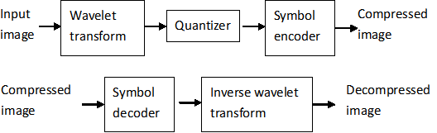

**Figure 2.2 Block diagram of Wavelet Transform based-image Compression and Decompression**

* FT: **time-unlimited** weighted sinusoids with different frequencies. No **temporal information**.
* WT: **limited duration** small waves with varying frequencies, which are called **wavelets**. WTs contain the temporal time information.

Thus, the WT is more adaptive.

For Example:

Lets we have an image of fingerprint and with the help of block diagram we can show the wavelet transform and its other process for compression and decompression. We use a threshold value and quantization for an image and encode it into compressed form after that we use the reverse process for decompress an image.

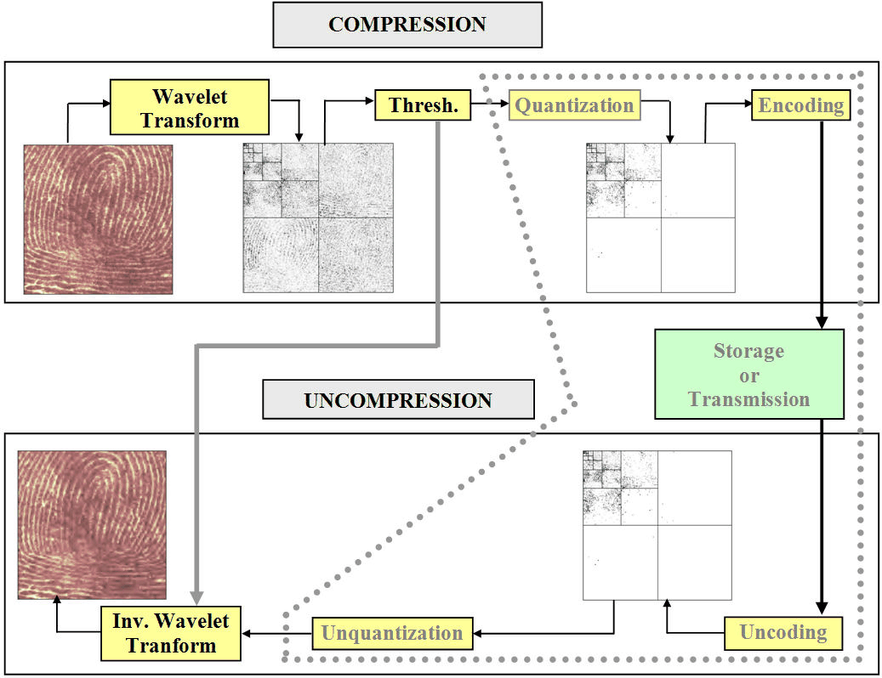

**Figure 2.3 Bock diagram of an image with compression and decompression**

**Linear Transform**

The first step in the compression or encoding is to transform the image from the spatial domain to the transformed domain using some known transform like: Discrete Fourier Transform (DFT), Discrete Cosine Transform(DCT), Discrete Wavelet Transform (DWT), Fractal Transform, and many more. Compressions of the original image is not easy, as the energy is scattered throughout the image. By transforming, a large portion of the energy can be concentrated in the low frequency-zone of the transform domain.

**2.4 Compression Ratio**

Compression ratio is defined as the ratio of an original image and compressed image. *Compression Ratio* = Original Image Size / Compressed Image Size

**2.5 PSNR (Peak Signal-to-Noise Ratio)**

PSNR is defined as the ratio of an original image and a coded/decoded image, PSNR is usually expressed in terms of the [logarithmic](http://en.wikipedia.org/wiki/Logarithm) [decibel](http://en.wikipedia.org/wiki/Decibel) (dB) scale. Typical quoted PSNR figures are in the range +25 to +35dB. Peak signal-to-noise ratio (PSNR) is the standard method for quantitatively comparing a compressed image with the original[6]. For an 8-bit grayscale image, the peak signal value is 255. PSNR is most commonly used to measure the quality of reconstruction of lossy compression [codec’s](http://en.wikipedia.org/wiki/Codec) (e.g., for [image compression](http://en.wikipedia.org/wiki/Image_compression)). The signal in this case is the original data, and the noise is the error introduced by compression. When comparing compression codec’s, PSNR is an *approximation* to human perception of reconstruction quality. Although a higher PSNR generally indicates that the reconstruction is of higher quality, in some cases it may not. One has to be extremely careful with the range of validity of this metric; it is only conclusively valid when it is used to compare results from the same codec (or codec type) and same content.

PSNR is most easily defined via the [mean squared error](http://en.wikipedia.org/wiki/Mean_squared_error) (*MSE*). Given a noise-free *m*×*n* monochrome image *I* and its noisy approximation *K*, *MSE* is defined as:

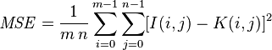

The PSNR is defined as:

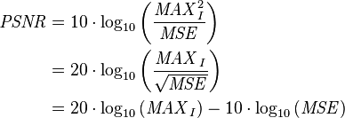

Here, *MAXI* is the maximum possible pixel value of the image. When the pixels are represented using 8 bits per sample, this is 255. More generally, when samples are represented using linear [PCM](http://en.wikipedia.org/wiki/Pulse-code_modulation) with *B* bits per sample, *MAXI* is 2B−1. For [color images](http://en.wikipedia.org/wiki/Color_image) with three [RGB](http://en.wikipedia.org/wiki/RGB) values per pixel, the definition of PSNR is the same except the MSE is the sum over all squared value differences divided by image size and by three. Alternately, for color images the image is converted to a different [color space](http://en.wikipedia.org/wiki/Color_space) and PSNR is reported against each channel of that color space, e.g., [Y Cb Cr](http://en.wikipedia.org/wiki/YCbCr) or [HSL](http://en.wikipedia.org/wiki/HSL_and_HSV). Typical values for the PSNR in [lossy](http://en.wikipedia.org/wiki/Lossy_compression) image and video compression are between 30 and 50 [dB](http://en.wikipedia.org/wiki/Decibel), where higher is better. Acceptable values for wireless transmission quality loss are considered to be about 20 dB to 25 dB. In the absence of noise, the two images *I* and *K* are identical, and thus the MSE is zero[7].

**2.6 Quantizer**

Quantizer is the key component in the transform compression framework that introduces non linearity in the system. It maps the transformed digital image to a discrete set or a discrete number. It is a lossy compression technique as it introduces an error in the image compression process i.e., it converts sequence of floating point numbers to sequence of integers. Scalar Quantization is the simplest quantization, as each input is treated separately in producing the output. In vector quantization, the input samples are clubbed together in groups called vectors, and then processed to give the output. Also, the quantization of the difference between the predicted value and the past samples is called predictive quantization. A good quantizer is one, which represents the original signal with minimum loss or distortion. For example: The SPIHT quantizer for compression. SPIHT is a fully embedded wavelet coding algorithm that progressively refines the most significant coefficients in the order of decreasing energy levels. It apportions the available bit budget between encoding the tree map (which indicates the location of the significant coefficients) and the significance information itself (which indicates the energy of the coefficients). It allows for precise rate control and affordable computational complexity. The SPIHT quantizer is reported to surpass other coding techniques such as DCT, EZT, etc.

**Effects of Quantization**

Let us show the effects of quantization on the visualization of the fingerprint image. This indexed image corresponds to a matrix of integers ranging between 0 and 255[8]. Through quantization we can decrease the number of colors which is here equal to 256.

The next figure illustrates how to decrease from 256 to 16 colors by working on the *values* of the original image.

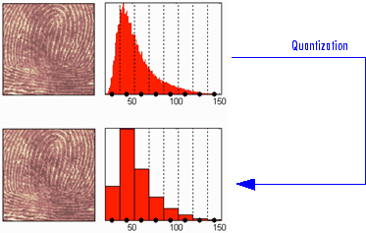

**Figure 2.4 (a) Quantization of an image before and after**

We can see on this figure:

* At the top
  + On the left: the original image
  + On the right: the corresponding histogram of *values*
* At the bottom
  + On the left: the reconstructed image
  + On the right: the corresponding histogram of *quantized values*

This quantization leads to a compression of the image. Indeed, with a fixed length binary code, 8 bits per pixel are needed to code 256 colors and 4 bits per pixel to code 16 colors. We notice that the image obtained after quantization is of good quality. However, within the framework of true compression, quantization is not used on the original image, but on its wavelet decomposition.

Let us decompose the fingerprint image at level 4 with the Haar wavelet. The histogram of wavelet coefficients and the quantized histogram are normalized so that the values vary between –1 and +1. The 15 intervals of quantization do not have the same length.

The next figure illustrates how to decrease information by binning on the wavelet *coefficient values* of the original image.

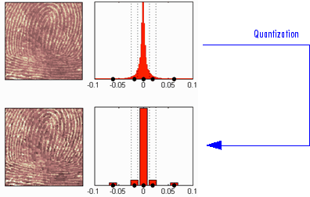

**Figure 2.4 (b) Quantization of an image before and after**

We can see on this figure:

* At the top
  + On left: the original image
  + On the right: the corresponding histogram (central part) of *coefficient values*
* At the bottom
  + On the left: the reconstructed image
  + On the right: the corresponding histogram (central part) of *quantized coefficient values*

The key point is that the histogram of the quantized coefficients is massively concentrated in the class centered in 0. Let us note that yet again the image obtained is of good quality.

**2.7 Entropy Coding**

After the quantization of the transformed values, entropy encoder further compress the quantized values to give additional compression. It is a lossless compression and is also reversible. The idea is to find a reversible mapping to the quantized values such that the average number of bits or symbols is minimized. For example, the Morse code assigns short codes to the letters appearing frequently whereas long codes are assigned to the letters appearing less frequently. Entropy coding works exactly like the Morse code. The two popular entropy-coding methods are Huffman coding and arithmetic coding.

**Embedded Zero tree Wavelets (EZW)**

For the low bit rate image coding the EZW is the best for its efficient and flexible compression algorithm [9]. The Previous LZW algorithm is not having the embedding features that are why it causes some problems during compression of images. The EZW having the embedding and adaptive arithmetic property that contains all the lower rate encoding of the same algorithms [10].This technique is flexible yet it is not essential to know the range of number being compressed[11].An encoder can stop it’s encoding process at any point and decoder can cease decoding at any point. Though it allow a final rate or final distortion metric to be met exactly, same for decoder still it’s produce the same image that is encoded. It will constantly produce the same compression ratio in comparison with all algorithms on test image.

**EZW’s Encoding Key**

The numerical importance is considered; the smallest wavelet is represented after the larger wavelets coefficient and sends this information to the encoder or decoder. EZW’s encoder encodes the location of the wavelets coefficients by using a predefined scan order. All of the lower subs bands are scanned sequentially before sending them to the higher sub bands .The EZW doesn’t require the prestored tables or code books, training or prior knowledge of the image source still it produce results. The EZW’s encoder doesn’t really compress anything it can record the wavelets coefficients. In such a way that the coefficients Can be compressed very efficiently. During the encoding process smallest and higher wavelets coefficients are maintained at any point. During the initial scan some of the coefficients are not found to be significant, the coordinates of these coefficients are in dominant list. In this scan sub bands are ordered, within each sub bands the set of coefficients are ordered. The magnitudes of those that have been found to be significant are in the subordinated list. Each list is scanned once for each threshold During a dominant pass, coefficients with coordinates on the dominant list, the coefficients that have not been found to be significant are compared to the threshold Ti to determine their significance and if is significant then their sign is recorded. A map indicating the result of a binary (Significant or insignificant) or a ternary (Positive significant, Negative significant or insignificant) decision is called a significant map. Set Partitioned into Hierarchical Trees (SPIHT).

Now days the demand of using digital images is increasing. The digital images are very large in size for that purpose it is very necessary to compress that images and to store them and send for transmission. With the help of using wavelets transform we can improve higher compression ratio. Over the last few-years there are different types of wavelets based image compression algorithms with embedded bit-stream have been developed such as EZW,SPIHT.SPIHT is an improved version of EZW[12].It improves the coding performance by reducing the redundant coefficients across sub bands.

**Features**

It has good image quality, high PSNR especially for color image. It is optimized for progressive image transmission It produces a fully embedded codec file. Efficient combination with error protection.

**Why SPIHT**

Though SPIHT is having embedded coding property it sorts the information on demand and requirement for powerful error correction codes decreases from the beginning to the end of the compressed file. If an error is detected but not corrected then decoder reject that data after point and still displays the image obtained with the bits received before the error. It generates two types of data the first sorting the information which needs error protection and second consist of uncompressed sign and refinement bits which don’t need special protection because they affect only one pixel[13].The wavelets pixel sets are divided into trees originating from the lowest resolution band. The coefficients are grouped into 2 by 2 arrays, except for the coefficient in band 1, which are offspring of a coefficient of a lower resolution band. Again the coefficients in the smallest band are also divided into 2 \*2 arrays. The coefficient at the top left corner of the array does not have any offspring and is known as the root nodes [14].

**Advantages**

* We can interrupt the decoding at any time and result of maximum possible details can be reused with 1-bit precision
* This is very useful in transmitting the files over the net since users with slower connection speed can download only a small part of the file, obtaining much more usable results when compared to other codec such as Progressive JPEG.
* It is very compact output bit stream with large bit variation. No additional entropy coding has to be applied.

**Disadvantages**

* It is vulnerable to bit corruption as a single bit error can introduce significant image distortion depending of its location
* It consists of bit synchronization property because a leak in bit transmission can lead to complete misinterpretation from the side of decoder.
* For SPIHT to be employed in real time application error handling and synchronization methods must be introduced in order to make the codec more resilient[15].

SPIHT has the problem that it implicitly locates the position of the significant coefficient .It is difficult to perform the operation on compressed data which is totally depend on the exact position of significant transform values[16].

**CHAPTER 3**

**LITERATURE SURVEY**

**3.1 Overview**

Previous works show that the method of modeling and ordering is very important to design a successful algorithm of wavelet based image compression and going to review and compare of different algorithm based on a novel scheme of in wavelet domain, pixel classification and sorting. Image, as an information source, can be transmitted via different representations; fewer bits required for representation, the more compression ratio (CR) could be achieved. In the Previous lossless image compression methods searches for smallest possible storage size for a particular image quality [9].Then in the next generation, lossy image compression methods are developed out of that EZW is one.

**3.2 Literature Review**

**1.** **“Image Compression Based on Wavelet Transform”**

In this paper author introduced the Fourier transform, wavelet transform and a few commonly used wavelet functions, band MatLab two-dimensional discrete wavelet transform image compression technology. Wavelet time-frequency analysis and multi-scale analysis of the more prominent features in the image compression. It has high compression ratio and compression speed. It also has a good signal to noise ratio[1]. It is largely to reduce the image storage space. Reduce the network communication to share bandwidth. It kept the original characteristics after compression, suitable for the demanding image compression. As an algorithm, the wavelet transform has good prospects in this field.

**2. “A Remote Sensing Image Compression Method Suited to Space-borne Application”**

In this paper author introduced a novel hybrid image compression technique for efficient storage and delivery of data is proposed. It is based on decomposing the data using daubechies-4 wavelet in combination with the lifting scheme and entropy encoding[22]. This scheme is concerned with the compression ratio, bits per pixel and peak signal to noise ratio. Experimental results illustrate that the proposed scheme is efficient and feasible in terms of compression ratio, bits per pixel and peak signal to noise ratio.

**3. “Comparative Analysis of an Optimal Image Compression using FDWT at Various Decomposition Level with Different Statistical Numerical Measures for Different Pixel Frame”**

In this paper author presented an image compression method suited to the space-borne application. To solve the problem of large-size RS images taking up large cache, the compression scheme based on overlap blocks was taken. The overlap blocks of the image were multi-levelly decomposed by lifting wavelet[23]. According to human visual characteristics, the lossless encoding method was used for the low-frequency sub-band most sensitive to human vision, and the bit-plane coding method was take for the remaining high-frequency sub-bands. Simulation results show that the algorithm can remove the blocking artifacts and realize the high quality image compression.

**4. “Integer to Integer Multi-wavelets for Lossless Image Compression”**

In this paper author discussed the comparative study of different wavelet-based image compression systems. When wavelet transform is applied to image compression, the chosen wavelet base affects the efficiency of signal strength, pixel values and the quality of the reconstructed image, because the property parameters of different wavelet bases are varied, it is very important to research the correlation between the wavelet base properties and image compression. They have discussed various statistical numerical measures and obtained results compared in terms of MSE, PSNR, Normalization and Compression Ratio with lower and higher pixel frames. The main objective of this research measure the quality of image with statistical numerical measures (PSNR, MSE respectively) using different wavelet families with suitable decomposition level. Different test image with 512 X 512 and 1024 X1024 pixel frames are used to evaluate the performance of image compression[24]. The final choice of optimal wavelet in image compression application depends on image quality, minimum error, optimum PSNR and computational complexity. The experiments are performed using different wavelets at various levels of decomposition. This results show that Discrete Mayer wavelet with second and fourth level decomposition yields better quality for Lena (1024 X 124) and quality has been degrade as lower pixel frame with fruits( 512 X 512)images. Our results provide a good reference for application developers to choose a go.

**5. “An Efficient Hybrid Image Compression Scheme based on Correlation of Pixels for Storage and Transmission of Images”**

In this paper author proposed the Lossless method of image compression and decompression using a simple coding technique called Huffman coding. This technique is simple in implementation and utilizes less memory. A software algorithm has been developed and implemented to compress and decompress the given image using Huffman coding techniques in a MATLAB platform[21].

**6. “Analysis of Various Image Compression Techniques”**

In this paper author analyzes various image compression techniques. In addition, specific methods are presented illustrating the application of such techniques to the real-world images. They have presented various steps involved in the general procedure for compressing images. They provided the basics of image coding with a discussion of vector quantization and one of the main technique of wavelet compression under vector quantization[20]. This analysis of various compression techniques provides knowledge in identifying the advantageous features and helps in choosing correct method for compression.

**7. “A New Lossless Method of Image Compression and Decompression using Huffman Coding Techniques”**

In this paper author an adaptive image compression algorithm is proposed based on the prediction of AC coefficients in Discrete Cosine Transform (DCT) block during reconstruction of image. In the prediction phase, DC values of the nearest neighbor DCT blocks are utilized to predict the AC coefficients of centre block. Surrounding DC values of a DCT blocks are adaptively weighed for AC coefficients prediction. Linear programming is used to calculate the weights with respect to the image content. Results show that this method is good in terms of good Peak Signal to Noise Ratio (PSNR) and less blocking artifacts. The proposed scheme has been demonstrated through several experiments including Lena[19]. Reconstructed image is of good quality with same compression ratio compared to the existing technique in the literature. In addition, an image watermarking algorithm is proposed using DCT AC coefficients obtained. The performance of the proposed watermarking scheme is measured in terms of PSNR and Normalized Cross Correlation (NCC). Further, this algorithm is robust for various attacks including JPEG compression on watermarked image.

**8. “Adaptive AC-Coefficient Prediction for Image Compression and Blind Watermarking”**

In this paper author a novel approach of information theory based Minimum Relative Entropy (MRE) and Entropy methods for image compression are discussed. A two stage compression process is performed through homogenous MRE method, and heterogeneous MRE. The compressed images are reconstructed through Region growing techniques[18]. The performance of image compression and restoration is analyzed by the estimation of parametric values such as Mean Square Error (MSE) and Peak Signal to Noise Ratio (PSNR). Higher the PSNR better the reconstruction process. Six radiographic medical images of various sizes are analyzed and Maximum PSNR of 33 is achieved.

**CHAPTER 4**

**PROPOSED ARCHITECTURE & METHODOLOGY**

Many signals and images of interest exhibit piecewise smooth behavior punctuated by transients. Speech signals are characterized by short bursts encoding consonants followed by steady-state oscillations indicative of vowels. Natural images have edges. Financial time series exhibit transient behavior, which characterize rapid upturns and downturns in economic conditions. Unlike the Fourier basis, wavelet bases are adept at sparsely representing piecewise regular signals and images, which include transient behavior.

### 4.1 Basics of Wavelet

A wavelet is a waveform of effectively limited duration that has an average value of zero and nonzero norm.

Compare wavelets with sine waves, which are the basis of Fourier analysis. Sinusoids do not have limited duration — they extend from minus to plus infinity. While sinusoids are smooth and predictable, wavelets tend to be irregular and asymmetric.

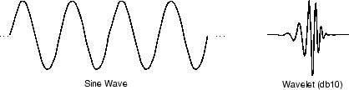

**Sin Wave Wavelet and dB Wavelet**

Fourier analysis consists of breaking up a signal into sine waves of various frequencies. Similarly, wavelet analysis is the breaking up of a signal into shifted and scaled versions of the original (or mother) wavelet[10].

Just looking at pictures of wavelets and sine waves, you can see intuitively that signals with sharp changes might be better analyzed with an irregular wavelet than with a smooth sinusoid.

It also makes sense that local features can be described better with wavelets that have local extent.

**What Can Wavelet Analysis Do?**

One major advantage afforded by wavelets is the ability to perform local analysis. Because wavelets are localized in time and scale, wavelet coefficients are able to localize abrupt changes in smooth signals and images.

This example shows you how wavelet coefficients localize a discontinuity in a sine wave.

Create a 1-Hz sine wave sampled at 100 Hz. The sine wave has a discontinuity at t=0.5 seconds.

t = linespace(0,1,100)';

x = sin(2\*pi\*t);

x1 = x-0.15;

y = zeros(size(x));

y(1:length(y)/2) = x(1:length(y)/2);

y(length(y)/2+1:end) = x1(length(y)/2+1:end);

stem(t,y,'markerfacecolor',[0 0 1]); xlabel('Seconds'); ylabel('Amplitude');

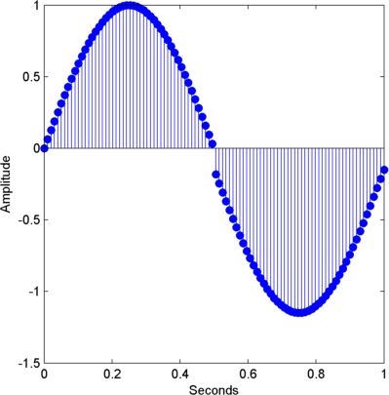

**Figure 4.1 Graph between Amplitude and Time**

Obtain the non decimated discrete wavelet transform of the sine wave using the 'sym2' wavelet and plot the wavelet (detail) coefficients along with the original signal.

[swa,swd] = swt(y,1,'sym2');

subplot(211)

stem(t,y,'markerfacecolor',[0 0 1]); title('Original Signal');

subplot(212)

stem(t,swd,'markerfacecolor',[0 0 1]); title('Level 1 Wavelet Coefficients');

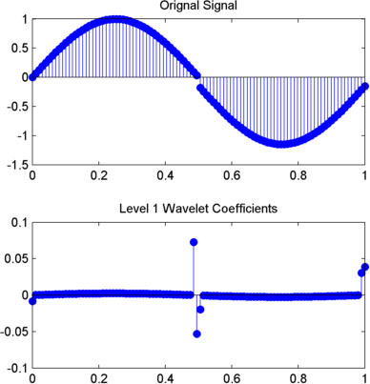

**Figure 4.2 Compare the Fourier coefficient magnitudes for the 1-Hz sine wave with and without the discontinuity**.

dftsig = fft([x y]);

dftsig = dftsig(1:length(y)/2+1,:);

df = 100/length(y);

freq = 0:df:50;

stem(freq,abs(dftsig));

xlabel('Hz'); ylabel('Magnitude');

legend('sine wave','sine wave with discontinuity');

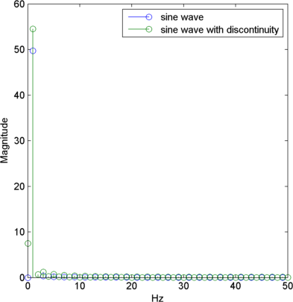

**Figure 4.3 Compare the level 1 wavelet coefficients for the sine wave with and without the discontinuity**.

There is minimal difference in the magnitudes of the Fourier coefficients. Because the discrete Fourier basis vectors have support over the entire time interval, the discrete Fourier transform does not detect the discontinuity as efficiently as the wavelet transform. Compare the level 1 wavelet coefficients for the sine wave with and without the discontinuity.

[~,swdx] = swt(x,1,'sym2');

subplot(211)

stem(t,swd); title('Sine Wave with Discontinuity (Wavelet Coefficients)');

subplot(212)

stem(t,swdx); title('Sine Wave (Wavelet Coefficients)');

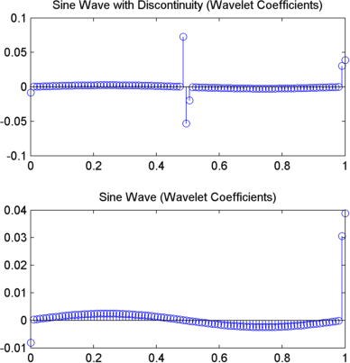

**Figure 4.4 The wavelet coefficients of the two signals demonstrate a significant difference.**

Wavelet analysis is often capable of revealing characteristics of a signal or image that other analysis techniques miss, like trends, breakdown points, discontinuities in higher derivatives, and self-similarity. Furthermore, because wavelets provide a different view of data than those presented by Fourier techniques, wavelet analysis can often significantly compress or de-noise a signal without appreciable degradation.

Transform based image compression schemes first involve the transformation of spatial in formation in to another domain[11]. For example, the DCT transforms an image into the frequency domain. The goal of the transformation is a compact, complete representation of the image. The transform should de-correlate the spatially distributed energy into fewer data samples such that no information is lost. Orthogonal transforms have the feature of eliminating redundancy in the transformed image. Compression occurs in the second step when the transformed image is quantized (i.e. when some data samples, usually those with insignificant energy-levels.are discarded). The inverse transform reconstructs the compressed image in the spatial domain. Since the quantization process is not invertible, the reconstruction cannot perfectly recreate the original image. This type of compression is called lossy; Figure 3.5 shows a block diagram of a lossy compression scheme. The Walsh Discrete wavelet transform, its applicability to image compression and a quantization technique that is used for image compression in this thesis. In transform based image compression, entropy coding typically follows the quantization stage. Entropy coding minimizes the redundancy in the bit stream and is fully invertible at the decoding end.

Input Reconstructed

X X’

QUANTIZER

INVERSE TRANSFORM

TRANSFORM

Image Image

**Figure 4.5: Block diagram of a transform based lossy compression system.**

Since we are primarily concerned with evaluating the performance of the wavelet transform in

compression, this thesis does not study the effects of entropy coding. A detailed description

of widely used entropy coding schemes is presented in [12].

**4.2 Walsh Transform**

The **Hadamard transform** (also known as the **Walsh–Hadamard transform**, **Hadamard–Rademacher–Walsh transform**, **Walsh transform**, or **Walsh–Fourier transform**) is an example of a generalized class of [Fourier transforms](https://en.wikipedia.org/wiki/Fourier_transform)[13]. It performs an [orthogonal](https://en.wikipedia.org/wiki/Orthogonal_matrix), [symmetric](https://en.wikipedia.org/wiki/Symmetric_matrix), [involution](https://en.wikipedia.org/wiki/Involution_%28mathematics%29), [linear operation](https://en.wikipedia.org/wiki/Linear_operator) on [real numbers](https://en.wikipedia.org/wiki/Real_number) (or [complex numbers](https://en.wikipedia.org/wiki/Complex_number), although the Hadamard matrices themselves are purely real).The Hadamard transform can be regarded as being built out of size-2 [discrete Fourier transforms](https://en.wikipedia.org/wiki/Discrete_Fourier_transform) (DFTs), and is in fact equivalent to a multidimensional DFT of size 2 x 2 x…2 x 2. It decomposes an arbitrary input vector into a superposition of [Walsh functions](https://en.wikipedia.org/wiki/Walsh_function).

The transform is named for the [French](https://en.wikipedia.org/wiki/France) [mathematician](https://en.wikipedia.org/wiki/Mathematician) [Jacques Hadamard](https://en.wikipedia.org/wiki/Jacques_Hadamard), the German-American mathematician [Hans Rademacher](https://en.wikipedia.org/wiki/Hans_Rademacher), and the American mathematician [Joseph L. Walsh](https://en.wikipedia.org/wiki/Joseph_L._Walsh). The Hadamard transform *Hm* is a 2*m* × 2*m* matrix, the [Hadamard matrix](https://en.wikipedia.org/wiki/Hadamard_matrix) (scaled by a normalization factor), that transforms 2*m* real numbers *xn* into 2*m* real numbers *Xk*. The Hadamard transform can be defined in two ways: [recursively](https://en.wikipedia.org/wiki/Recursively), or by using the [binary](https://en.wikipedia.org/wiki/Binary_numeral_system) ([base](https://en.wikipedia.org/wiki/Base_%28exponentiation%29)-2) representation of the indices *n* and *k*. Recursively, we define the 1 × 1 Hadamard transform *H*0 by the [identity](https://en.wikipedia.org/wiki/Identity_matrix) *H*0 = 1, and then define *Hm* for *m* > 0 by:

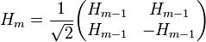

where the 1/√2 is a normalization that is sometimes omitted. Thus, other than this normalization factor, the Hadamard matrices are made up entirely of 1 and −1. Equivalently, we can define the Hadamard matrix by its (*k*, *n*)-th entry by writing

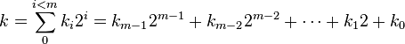

and

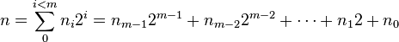

where the *kj* and *nj* are the binary digits (0 or 1) of *k* and *n*, respectively. Note that for the element in the top left corner, we define: . In this case, we have:

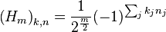

This is exactly the multidimensional DFT, normalized to be [unitary](https://en.wikipedia.org/wiki/Unitary_operator), if the inputs and outputs are regarded as multidimensional arrays indexed by the *nj* and *kj*, respectively.

Some examples of the Hadamard matrices follow.

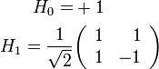

(This *H*1 is precisely the size-2 DFT. It can also be regarded as the [Fourier transform](https://en.wikipedia.org/wiki/Fourier_transform) on the two-element *additive* group of **Z**/(2).)

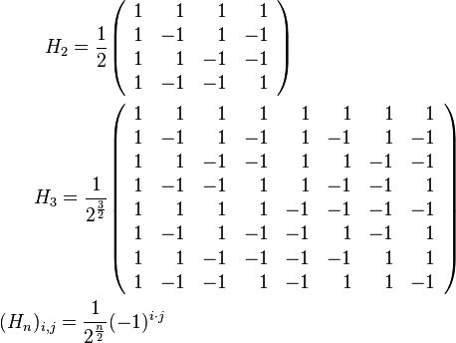

where is the bitwise dot product of the binary representations of the numbers i and j. For example, if , then , agreeing with the above (ignoring the overall constant). Note that the first row, first column of the matrix is denoted by .

The rows of the Hadamard matrices are the [Walsh functions](https://en.wikipedia.org/wiki/Walsh_function).

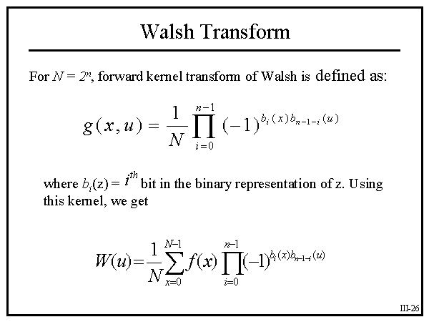

Here we calculate the matrix of Walsh coefficients

Lets look at N=8 and find the matrix g(x,u) :

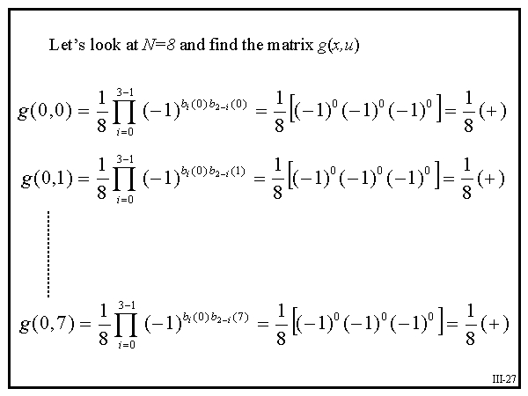

Looking at this 8 x 8 matrix, realize that it is a symmetric one.

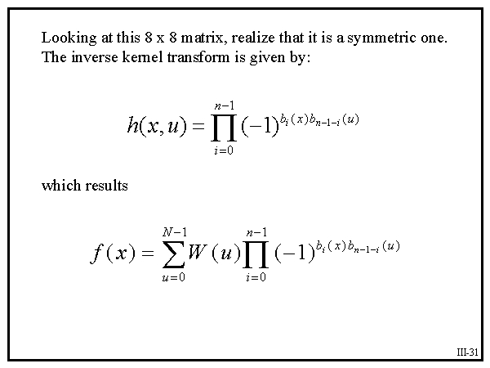

**4.2.1 Two-Dimensional Walsh Transform**

Note that the only difference between the forward and inverse transform is 1/N constant. Now,

We go to 2-dimensional transformation we will have:

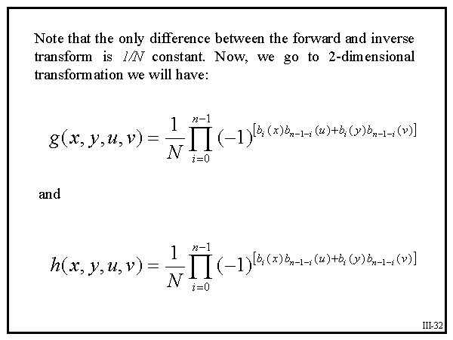

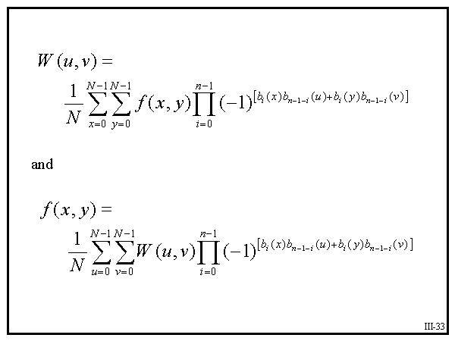

**4.2.2 Properties of Walsh Transforms**

Three Observations:

* By splitting constant 1/N between the forward and inverse 2-dimensional kernels, we have made them identical which works perfectly for image processing application.
* It is possible to separate two-dimensional transform into two one-dimensional ones.

Result of these two observations suggests that to take 2-D Walsh Transform, it is possible to take two 1-D Walsh Transform and get the same result. Further more, they suggest that same algorithm can be used to perform inverse Walsh Transform.

**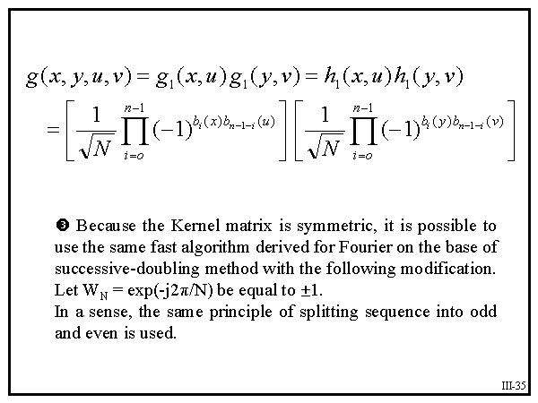**

* Because the kernel matrix is symmetric, it is possible to use the same fast algorithm derived for Fourier on the base of successive-doubling method with the following modification.

Let WN =exp(-j2Π/N) be equal to +-1. In a sense, the same principle of splitting sequence into odd and even is used.

**4.3 WAVELET FAMILIES**

Wavelet families and family members and we use Daubechies wavelet.

Haar haar

Daubechies db

Symlets sym

Coiflets coif

BiorSplines bior

Shannon shan

**4.3.1 Daubechies Wavelets**

Ingrid Daubechies, one of the brightest stars in the world of wavelet research, invented what are

called compactly supported orthonormal wavelets[14]. The names of the Daubechies family wavelets are written dbN, where N is the order, and db the “surname” of the wavelet. The Daubechies wavelets, based on the work of [Ingrid Daubechies](http://en.wikipedia.org/wiki/Ingrid_Daubechies), are a family of [orthogonal wavelets](http://en.wikipedia.org/wiki/Orthogonal_wavelet) defining a [discrete wavelet transform](http://en.wikipedia.org/wiki/Discrete_wavelet_transform) and characterized by a maximal number of vanishing [moments](http://en.wikipedia.org/wiki/Moment_%28mathematics%29) for some given [support](http://en.wikipedia.org/wiki/Support_%28mathematics%29). With each wavelet type of this class, there is a scaling function (called the *father wavelet*) which generates an orthogonal multi-resolution analysis.

db2 db3 db4

db5 db6 db7

db8 db9 db10

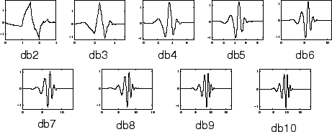

**Figure 4.6 Daubechies Wavelet Families**

The Daubechies wavelets are orthogonal wavelets which is energy or norm preserving. There are a number of Daubechies wavelets. The easiest way to understand this transform is just to treat them as simple generations of the Daub4 transform with the scaling and translation factors. The most apparent difference between each of them is the length of the supports of their scaling signals and wavelets. Daub4 wavelet is the same as the Haar wavelet. Daub4 wavelet preserves the energy due to its orthogonality. Daub4 transform is suitable for identifying features of the signal that are related to turning points in its graph. Now, one might wonder why we have so many different DaubN and their advantages, and disadvantages. Daub6 often produces smaller size fluctuation values than those produced by D4 transform. The types of signals for which this occurs are the ones that are obtained from the sample of analog signals that are at least three times continuously differentiable. These kinds of signals are approximated better, over a large proportion of their values by quadratic approximations. The curve graphs of quadratic functions enable then to provide superior approximations to the parts of the signal that are near to the turning points in its graph. So for signal compression Daub6 transform generally does a better job. However, the fact that Daub4 being better in approximating signals better approximated by linear approximation[10] .

 

(a)Scaling function (b) Wavelet function

**Figure 4.7 Db10 wavelet**

## 4.3.2 Properties

In general the Daubechies wavelets are chosen to have the highest number *A* of vanishing moments, (this does not imply the best smoothness) for given support width *N=2A*, and among the 2*A*−1 possible solutions the one is chosen whose scaling filter has external phase. The wavelet transform is also easy to put into practice using the [fast wavelet transform](http://en.wikipedia.org/wiki/Fast_wavelet_transform). Daubechies wavelets are widely used in solving a broad range of problems, e.g. self-similarity properties of a signal or [fractal](http://en.wikipedia.org/wiki/Fractal) problems, signal discontinuities, etc. The Daubechies wavelets are not defined in terms of the resulting scaling and wavelet functions; in fact, they are not possible to write down in [closed form](http://en.wikipedia.org/wiki/Closed_form_expression). The graphs below are generated using the [cascade algorithm](http://en.wikipedia.org/wiki/Cascade_algorithm), a numeric technique consisting of simply inverse-transforming [1 0 0 0 0 ... ] an appropriate number of times. Daubechies orthogonal wavelets D2-D10 (even index numbers only) are commonly used. The index number refers to the number *N* of coefficients. Each wavelet has a number of *zero moments* or *vanishing moments* equal to half the number of coefficients. For example, D2 (the [Haar wavelet](http://en.wikipedia.org/wiki/Haar_wavelet)) has one vanishing moment, D4 has two, etc. A vanishing moment limits the wavelet's ability to represent [polynomial](http://en.wikipedia.org/wiki/Polynomial) behavior or information in a signal. For example, D2, with one moment, easily encodes polynomials of one coefficient, or constant signal components. D4 encodes polynomials with two coefficients, i.e. constant and linear signal components; and D6 encodes 3-polynomials, i.e. constant, linear and [quadratic](http://en.wikipedia.org/wiki/Quadratic_polynomial) signal components. This ability to encode signals is nonetheless subject to the phenomenon of *scale leakage*, and the lack of shift-invariance, which arise from the discrete shifting operation (below) during application of the transform. Sub-sequences which represent linear, [quadratic](http://en.wikipedia.org/wiki/Quadratic_polynomial) (for example) signal components are treated differently by the transform depending on whether the points align with even- or odd-numbered locations in the sequence. The lack of the important property of [shift-invariance](http://en.wikipedia.org/wiki/Translational_invariance), has led to the development of several different versions of a [shift-invariant (discrete) wavelet transform](http://en.wikipedia.org/wiki/Shift_invariant_wavelet_transform).

After studying various image compression methods have been presented, aiming to fill-in missing techniques which comes in our mind that Daubechies-Wavelets with arithmetic coding. All these above approaches work at pixel level and are some good level recovering small flaws and thin structures. Additionally, after goes through these literature we presents Daubechies-Wavelets with arithmetic coding, based approaches for image compression, presented below:

**4.4 Proposed Architecture**

Architecture and algorithms of our proposed method for image compression is given below:



**Figure 4.8: Flow chart of proposed method**

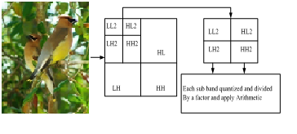

**Figure 4.9: Shows 2D-WWT compression algorithm steps for high frequency domains, and for low frequency domains**

Major steps of our proposed method for image compression summarizing following steps:

1. Choose the input image from database which you want to compress.

2. Divide selected input image into 8x8 blocks.

3. Apply two levels discrete wavelet transforms.

4. Apply 2D Walsh Wavelet Transform on each 8x8 block of the low-frequency sub-band.

Apply Walsh Wavelet transform and then using arithmetic coding for compress an image.

Step 4 consists of the following:

4.1. Two Levels Discrete Wavelet Transform.

4.2. Apply 2D Walsh-Wavelet Transform on each 8x8 block of the low frequency sub-band.

4.3. Split all values form each transformed block 8x8.

4.4. Compress each sub-band by using Arithmetic coding, the first part of Walsh Wavelet compression steps for high frequency, domains, and then second part of Walsh Wavelet compression steps for low frequency.

5. Split all DC values form each transformed block 8x8

6. Apply for compression each sub-band by using Arithmetic coding

7. Output image obtained by the compression.

**CHAPTER 5**

**IMPLEMENTATION DETAIL AND RESULT ANALYSIS**

**5.1 Implementation Detail**

The experiments presented in this thesis shows Daubechies wavelet-based “Image Compression Using 2-D Walsh Wavelet Transform". The quantitative comparison is made using PSNR and the qualitative comparison is made using the Daubechies family (db2-d10) and Compression ratio factor with the quantization factor values(.05-.5). We present a comprehensive correlation analysis of the quantitative and qualitative results. In addition, we compare the quantitative and qualitative results to the original image and after decompression image. The following summarizes the varying factors in the experiments. Here we use Matlab for the implementing our work.

MATLAB (matrix laboratory) is a [numerical computing](http://en.wikipedia.org/wiki/Numerical_analysis) environment and [fourth-generation programming language](http://en.wikipedia.org/wiki/Fourth-generation_programming_language). Developed by [Maths Works](http://en.wikipedia.org/wiki/MathWorks), MATLAB allows [matrix](http://en.wikipedia.org/wiki/Matrix_%28mathematics%29) manipulations, plotting of [functions](http://en.wikipedia.org/wiki/Function_%28mathematics%29) and data, implementation of [algorithms](http://en.wikipedia.org/wiki/Algorithm), creation of [user interfaces](http://en.wikipedia.org/wiki/User_interface), and interfacing with programs written in other languages, including [C](http://en.wikipedia.org/wiki/C_%28programming_language%29), [C++](http://en.wikipedia.org/wiki/C%2B%2B), [Java](http://en.wikipedia.org/wiki/Java_%28programming_language%29), and [Fortran](http://en.wikipedia.org/wiki/Fortran).

Although MATLAB is intended primarily for numerical computing, an optional toolbox uses the [MuPAD](http://en.wikipedia.org/wiki/MuPAD) [symbolic engine](http://en.wikipedia.org/wiki/Computer_algebra_system), allowing access to [symbolic computing](http://en.wikipedia.org/wiki/Symbolic_computing) capabilities. An additional package, [Simulink](http://en.wikipedia.org/wiki/Simulink), adds graphical multi-domain simulation and [Model-Based Design](http://en.wikipedia.org/wiki/Model_based_design) for [dynamic](http://en.wikipedia.org/wiki/Dynamical_system) and [embedded systems](http://en.wikipedia.org/wiki/Embedded_systems).

In 2004, MATLAB had around one million users across industry and academia. MATLAB users come from various backgrounds of [engineering](http://en.wikipedia.org/wiki/Engineering), [science](http://en.wikipedia.org/wiki/Science), and [economics](http://en.wikipedia.org/wiki/Economics). MATLAB is widely used in academic and research institutions as well as industrial enterprises. [Cleve Moler](http://en.wikipedia.org/wiki/Cleve_Moler), the chairman of the [computer science](http://en.wikipedia.org/wiki/Computer_science) department at the [University of New Mexico](http://en.wikipedia.org/wiki/University_of_New_Mexico), started developing MATLAB in the late 1970s. He designed it to give his students access to [LINPACK](http://en.wikipedia.org/wiki/LINPACK) and [EISPACK](http://en.wikipedia.org/wiki/EISPACK) without them having to learn [Fortran](http://en.wikipedia.org/wiki/Fortran). It soon spread to other universities and found a strong audience within the [applied mathematics](http://en.wikipedia.org/wiki/Applied_mathematics) community. [Jack Little](http://en.wikipedia.org/wiki/John_N._Little), an engineer, was exposed to it during a visit Moler made to [Stanford University](http://en.wikipedia.org/wiki/Stanford_University) in 1983. Recognizing its commercial potential, he joined with Moler and Steve Bangert. They rewrote MATLAB in [C](http://en.wikipedia.org/wiki/C_%28programming_language%29) and founded [MathWorks](http://en.wikipedia.org/wiki/MathWorks) in 1984 to continue its development. These rewritten libraries were known as JACKPAC. In 2000, MATLAB was rewritten to use a newer set of libraries for matrix manipulation, [LAPACK](http://en.wikipedia.org/wiki/LAPACK). MATLAB was first adopted by researchers and practitioners in [control engineering](http://en.wikipedia.org/wiki/Control_engineering), Little's specialty, but quickly spread to many other domains. It is now also used in education, in particular the teaching of [linear algebra](http://en.wikipedia.org/wiki/Linear_algebra) and [numerical analysis](http://en.wikipedia.org/wiki/Numerical_analysis), and is popular amongst scientists involved in [image processing](http://en.wikipedia.org/wiki/Image_processing). In this work we use Matlab R2007b version.

**5.2 Results for different Natural color Images:**

**5.2.1 Results for Parrot**

Parrot, image in compression research, consists primarily of colored content. Compression with CRF always yields a lower PSNR when we use different wavelet form of Db.

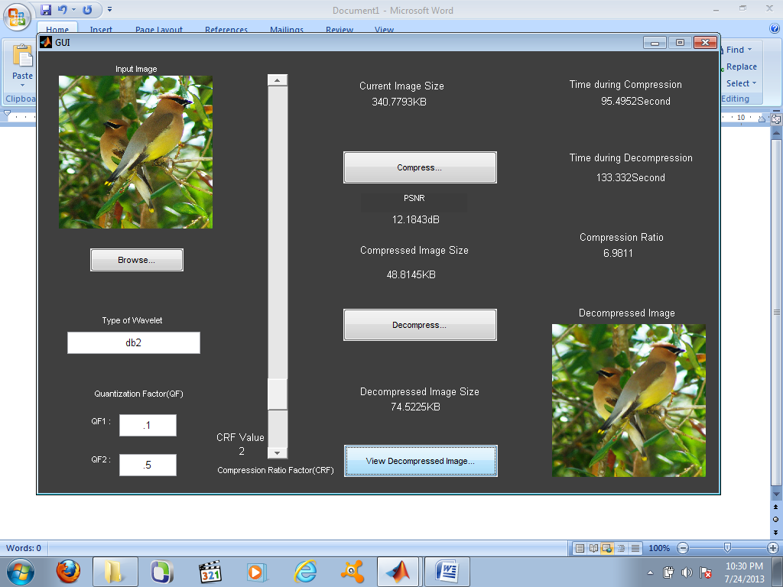

**Figure 5.1 Parrot image tested in db2 with CRF value 2**

In this figure we use db2 wavelet form on the input image of 340 kb in size and QF form [.1-.5] with CRF value is 2, On compressing we got 48.81 kb and PSNR is 12.18 Db. We estimated the time during compression that is 95.49 sec . After that when we decompress the image the size is 74.5 kb and time during decompression is 133.3 sec. The compression ratio for that process is 6.98 .

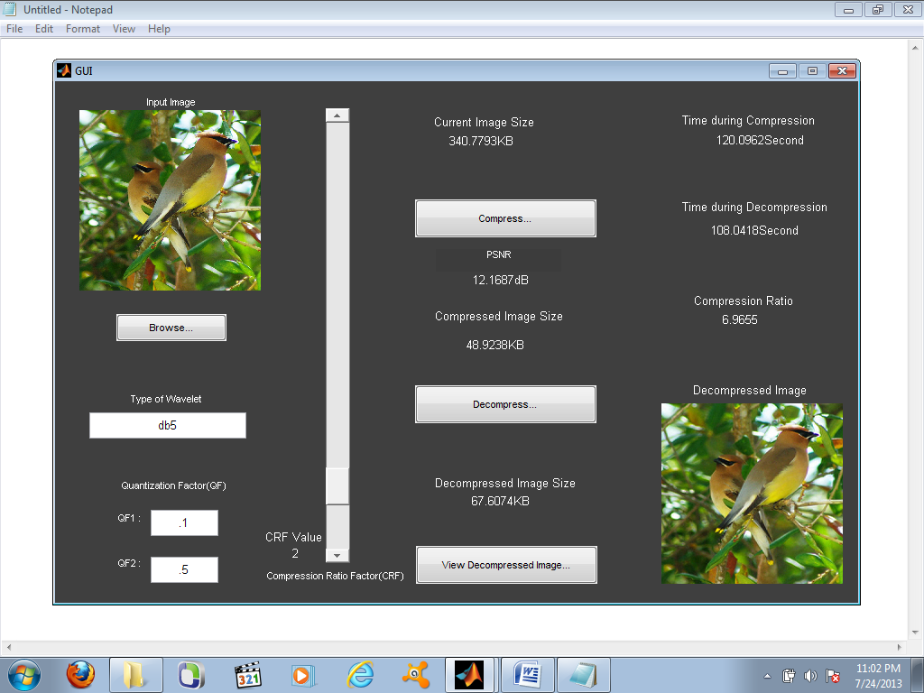

**Figure 5.2 Parrot image tested in db5 with CRF value 2**

In this figure we use db5 wavelet form on the input image of 340.7 kb in size and QF form [.1-.5] with CRF value is 2, On compressing we got 48.92 kb and PSNR is 12.16 dB. We estimated the time during compression that is 120.09 sec . After that when we decompress the image the size is 67.6 kb and time during decompression is 108.04 sec. The compression ratio for that process is 6.96 .

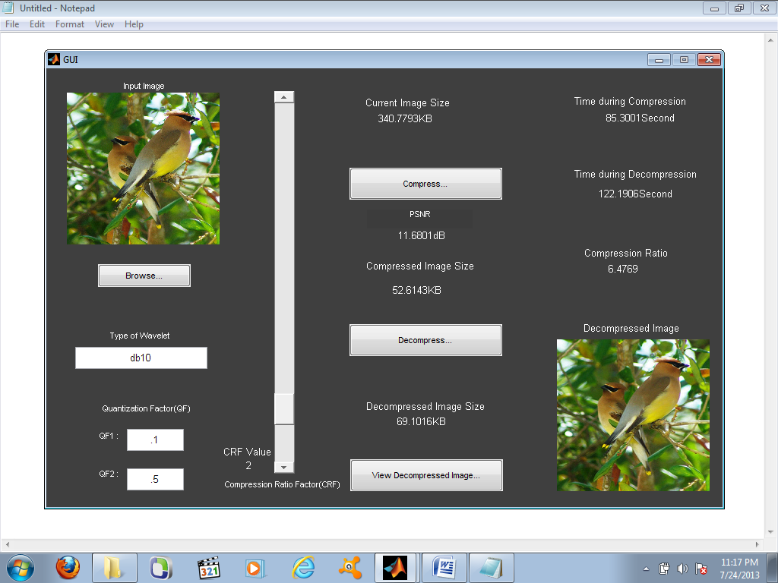

**Figure 5.3 Parrot image tested in db10 with CRF value 2**

In this figure we use db10 wavelet form on the input image of 340.7 kb in size and QF form [.1-.5] with CRF value is 2, On compressing we got 52.61 kb and PSNR is 11.68 dB. We estimated the time during compression that is 85.30 sec . After that when we decompress the image the size is 69.1 kb and time during decompression is 122.1 sec. The compression ratio for that process is 6.47 .

**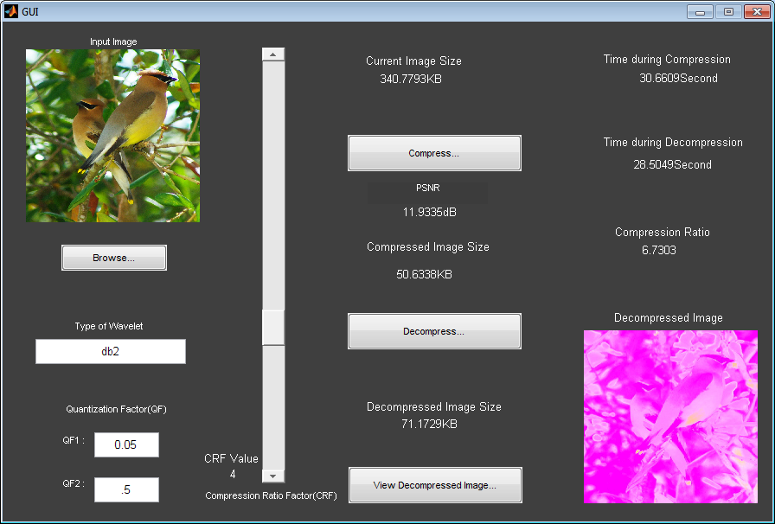**

**Figure 5.4 Parrot image tested in db2 with CRF value 4**

In this figure we use db2 wavelet form on the input image of 340.7 kb in size and QF form [.05-.5] with CRF value is 4, On compressing we got 52.63 kb and PSNR is 11.93 dB. We estimated the time during compression that is 30.66 sec . After that when we decompress the image the size is 71.17 kb and time during decompression is 28.5 sec. The compression ratio for that process is 6.7 .

**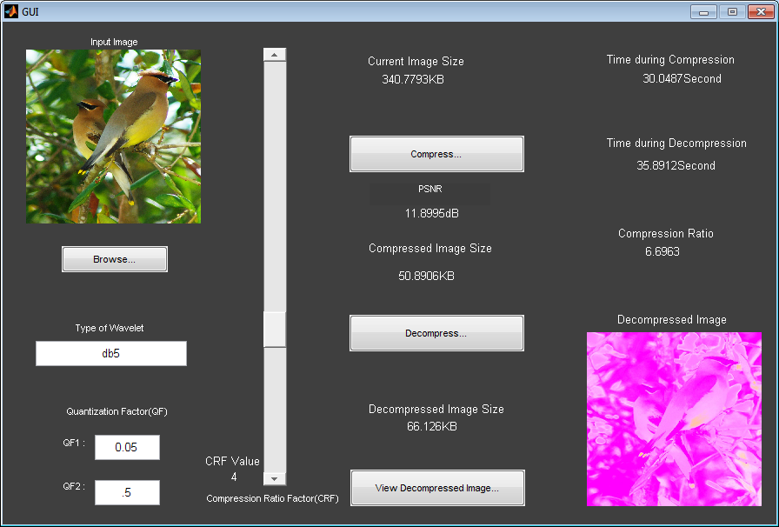**

**Figure 5.5 Parrot image tested in db5 with CRF value 4**

In this figure we use db5 wavelet form on the input image of 340.7 kb in size and QF form [.05-.5] with CRF value is 4, On compressing we got 50.89 kb and PSNR is 11.89 dB. We estimated the time during compression that is 30.04 sec . After that when we decompress the image the size is 66.12 kb and time during decompression is 35.89 sec. The compression ratio for that process is 6.69.

**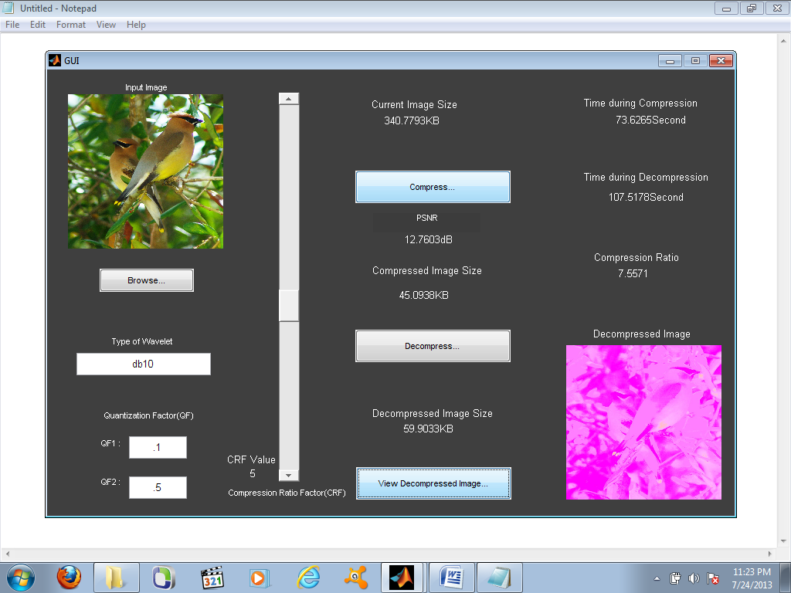**

**Figure 5.6 Parrot image tested in db10 with CRF value 5**

In this figure we use db10 wavelet form on the input image of 340.7 kb in size and QF form [.1-.5] with CRF value is 5, On compressing we got 45.09 kb and PSNR is 12.76 dB. We estimated the time during compression that is 73.65 sec . After that when we decompress the image the size is 59.90 kb and time during decompression is 107.51 sec. The compression ratio for that process is 7.55.

**5.2.2 Results for CAR**

**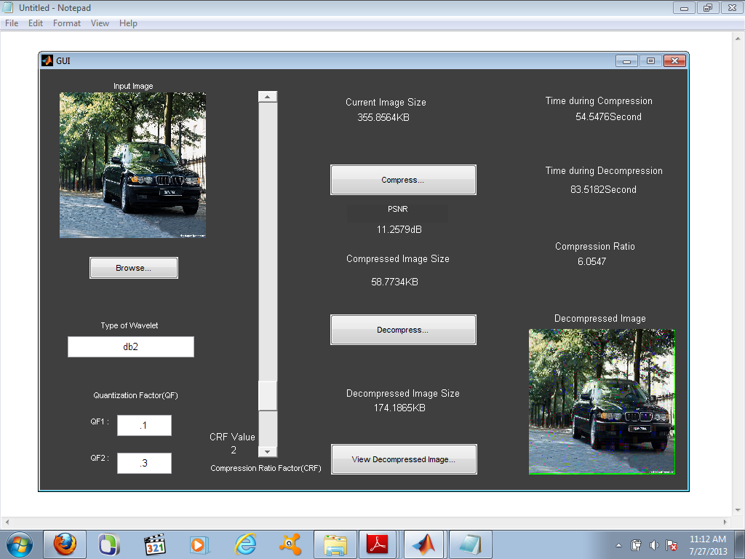**

**Figure 5.7 Car image tested in db2 with CRF value 2**

In this figure we use db2 wavelet form on the input image of 355.85 kb in size and QF form [.1-.5] with CRF value is 2, On compressing we got 58.77 kb and PSNR is 11.25 dB. We estimated the time during compression that is 54.54 sec . After that when we decompress the image the size is 174.18 kb and time during decompression is 85.51 sec. The compression ratio for that process is 6.05.

**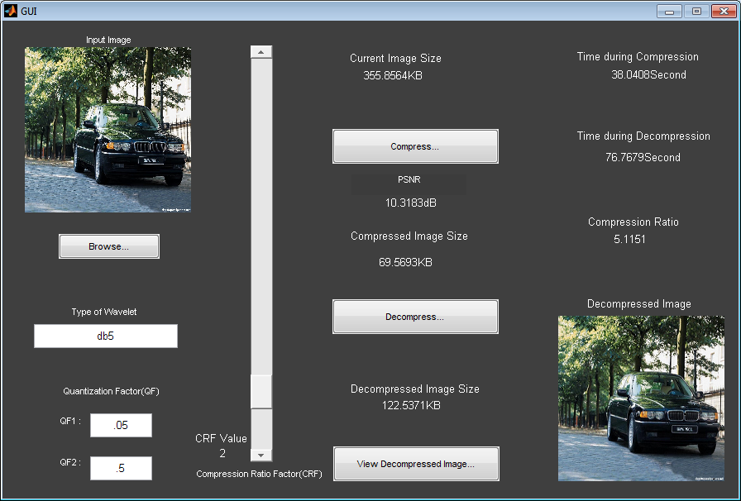**

**Figure 5.8 Car image tested in db5 with CRF value 2**

In this figure we use db5 wavelet form on the input image of 355.85 kb in size and QF form [.05-.5] with CRF value is 2, On compressing we got 69.56 kb and PSNR is 10.31 dB. We estimated the time during compression that is 38.04 sec . After that when we decompress the image the size is 122.53 kb and time during decompression is 76.76 sec. The compression ratio for that process is 5.11.

**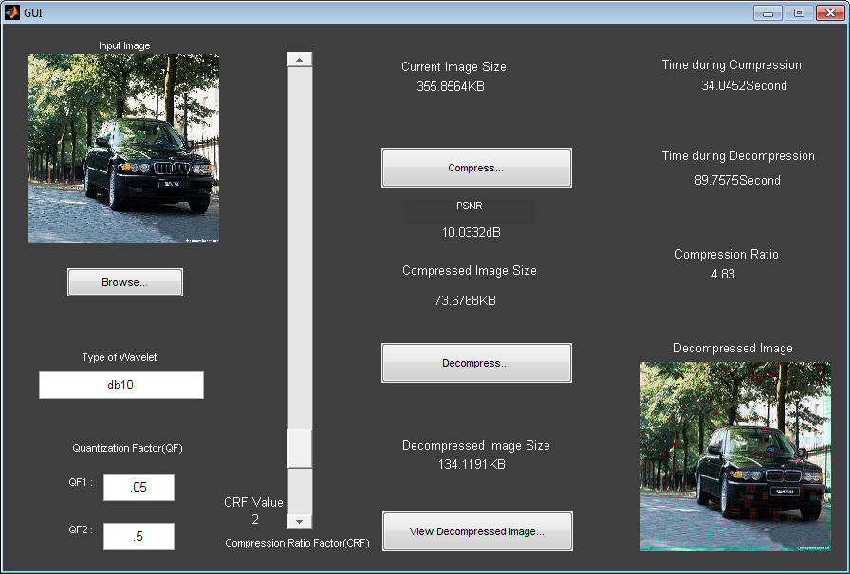**

**Figure 5.9 Car image tested in db10 with CRF value 2**

In this figure we use db10 wavelet form on the input image of 355.85 kb in size and QF form [.05-.5] with CRF value is 2, On compressing we got 73.67 kb and PSNR is 10.03 dB. We estimated the time during compression that is 34.04 sec . After that when we decompress the image the size is 134.11 kb and time during decompression is 89.75 sec. The compression ratio for that process is 4.83.

**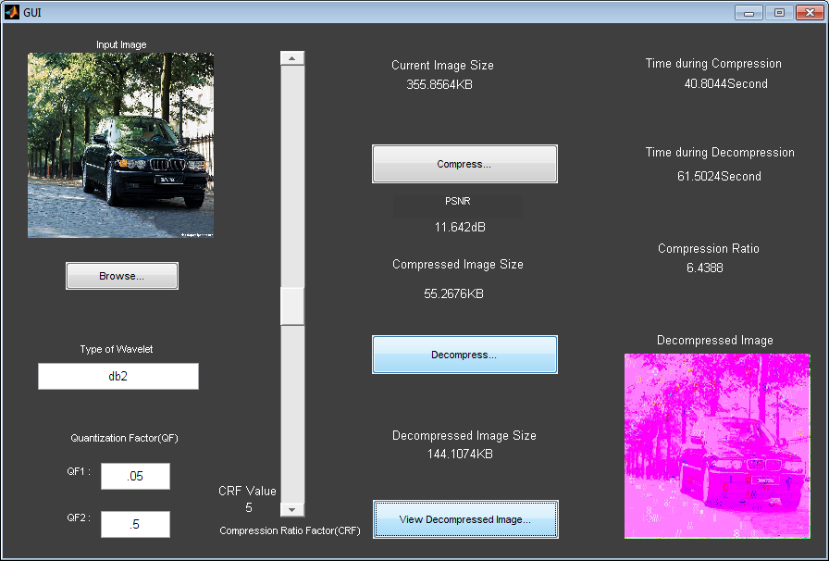**

**Figure 5.10 Car image tested in db2 with CRF value 5**

In this figure we use db2 wavelet form on the input image of 355.85 kb in size and QF form [.05-.5] with CRF value is 5, On compressing we got 55.26 kb and PSNR is 11.64 dB. We estimated the time during compression that is 40.80 sec . After that when we decompress the image the size is 144.10 kb and time during decompression is 61.50 sec. The compression ratio for that process is 6.43.

**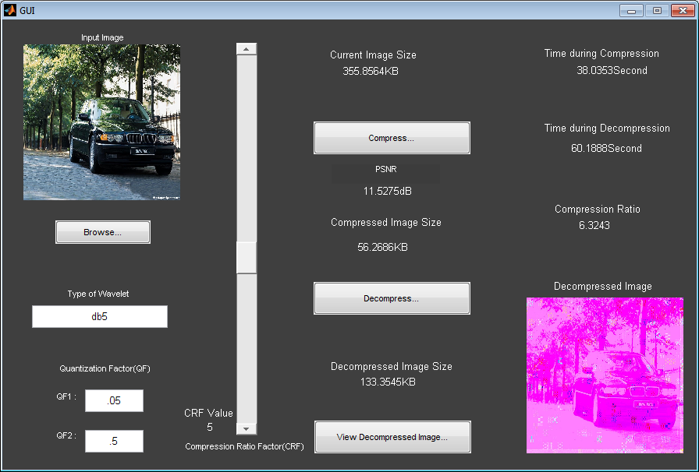**

**Figure 5.11 Car image tested in db5 with CRF value 5**

In this figure we use db5 wavelet form on the input image of 355.85 kb in size and QF form [.05-.5] with CRF value is 5, On compressing we got 56.26 kb and PSNR is 10.31 dB. We estimated the time during compression that is 38.03 sec . After that when we decompress the image the size is 133.35 kb and time during decompression is 60.18 sec. The compression ratio for that process is 6.32 .

**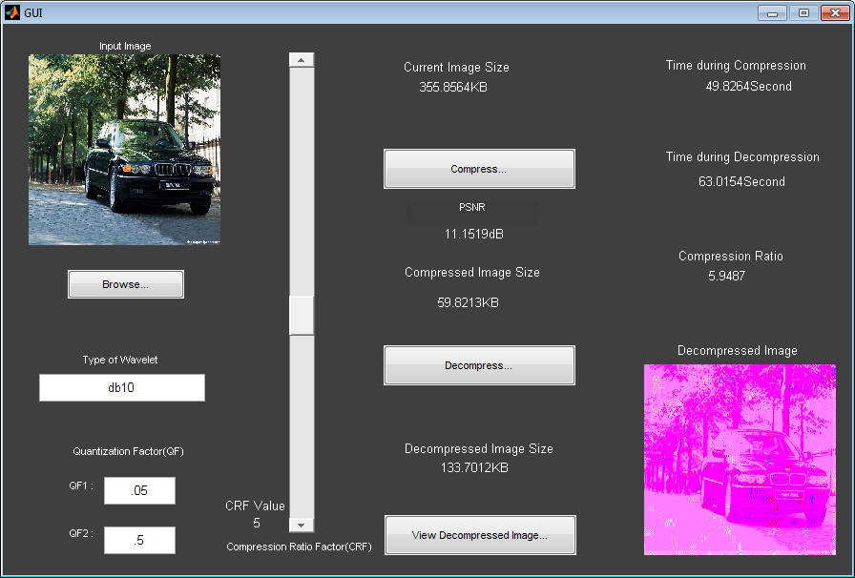**

**Figure 5.12 Car image tested in db210 with CRF value 5**

In this figure we use db10 wavelet form on the input image of 355.85 kb in size and QF form [.05-.5] with CRF value is 5, On compressing we got 69.56 kb and PSNR is 11.15 dB. We estimated the time during compression that is 49.82 sec . After that when we decompress the image the size is 133.70 kb and time during decompression is 63.01 sec. The compression ratio for that process is 5.94.

**5.2.3 Results for CITY**

**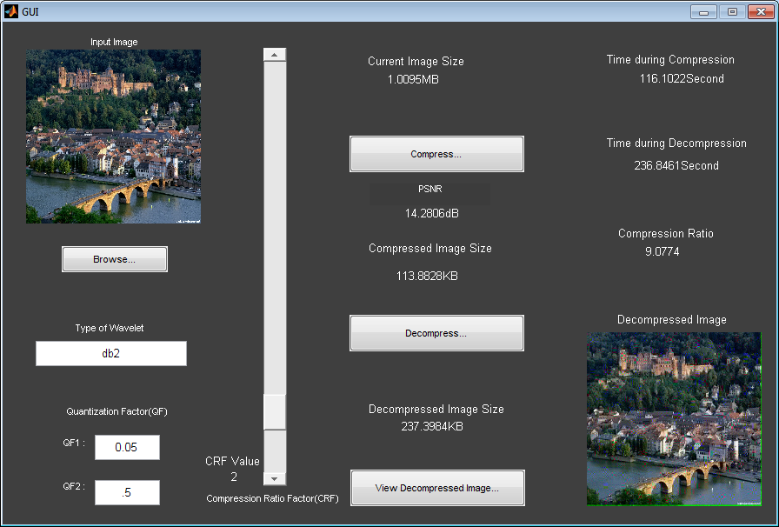**

**Figure 5.13 Car image tested in db2 with CRF value 2**

In this figure we use db2 wavelet form on the input image of 1.00 Mb in size and QF form [.05-.5] with CRF value is 2, On compressing we got 113.82 kb and PSNR is 14.28 dB. We estimated the time during compression that is 116.10 sec . After that when we decompress the image the size is 236.39 kb and time during decompression is 236.84 sec. The compression ratio for that process is 9.07 .

**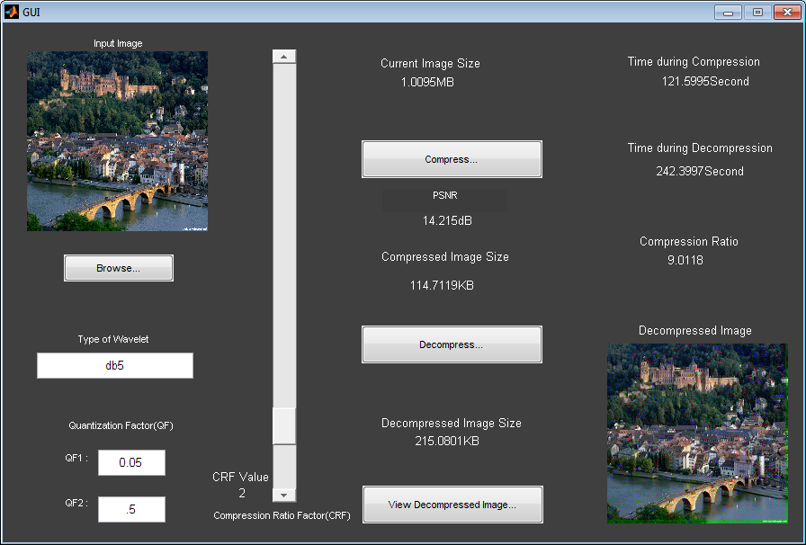**

**Figure 5.14 Car image tested in db5 with CRF value 2**

In this figure we use db5 wavelet form on the input image of 1.00 Mb in size and QF form [.05-.5] with CRF value is 2, On compressing we got 114.71 kb and PSNR is 14.21 dB. We estimated the time during compression that is 121.59 sec . After that when we decompress the image the size is 215.08 kb and time during decompression is 242.39 sec. The compression ratio for that process is 9.01 .

**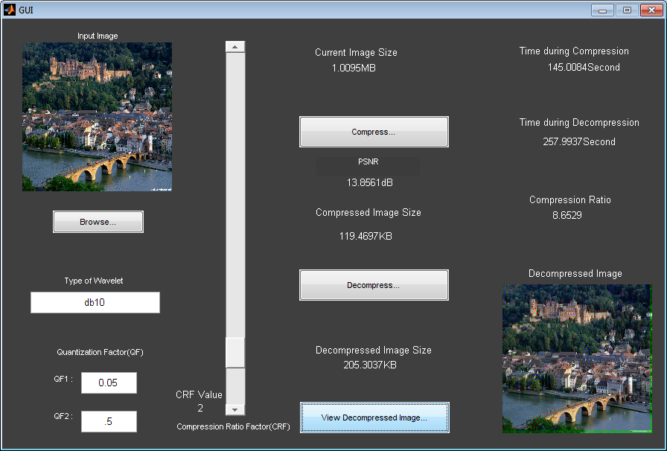**

**Figure 5.15 Car image tested in db10 with CRF value 2**

In this figure we use db10 wavelet form on the input image of 1.00 Mb in size and QF form [.05-.5] with CRF value is 2, On compressing we got 119.46 kb and PSNR is 13.85 dB. We estimated the time during compression that is 145.0 sec . After that when we decompress the image the size is 205.30 kb and time during decompression is 257.99 sec. The compression ratio for that process is 9.07 .

**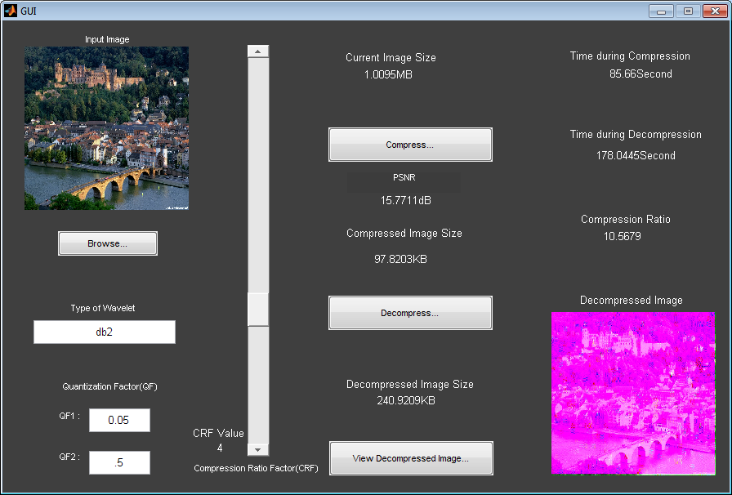**

**Figure 5.16 Car image tested in db2 with CRF value 4**

In this figure we use db2 wavelet form on the input image of 1.00 Mb in size and QF form [.05-.5] with CRF value is 4, On compressing we got 97.82 kb and PSNR is 15.77 dB. We estimated the time during compression that is 85.66 sec . After that when we decompress the image the size is 240.92 kb and time during decompression is 178.04 sec. The compression ratio for that process is 10.56 .

**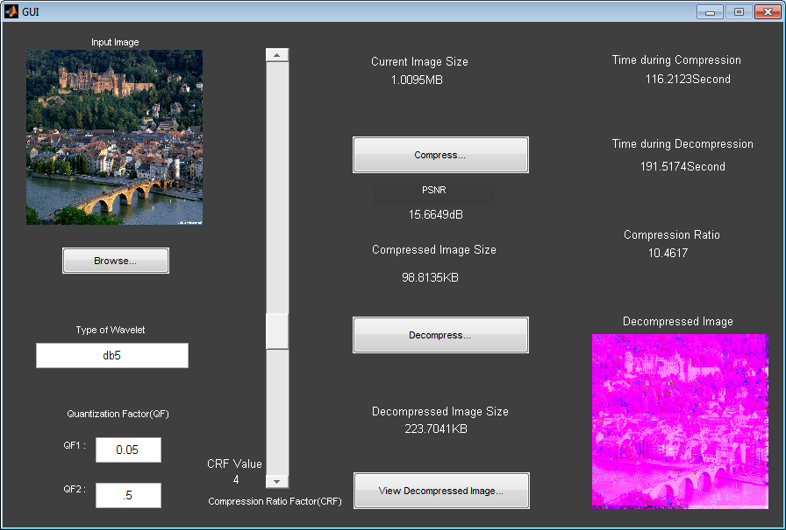**

**Figure 5.17 Car image tested in db5 with CRF value 4**

In this figure we use db5 wavelet form on the input image of 1.00 Mb in size and QF form [.05-.5] with CRF value is 4, On compressing we got 98.81 kb and PSNR is 15.66 dB. We estimated the time during compression that is 116.21 sec . After that when we decompress the image the size is 223.70 kb and time during decompression is 191.51 sec. The compression ratio for that process is 10.46 .

**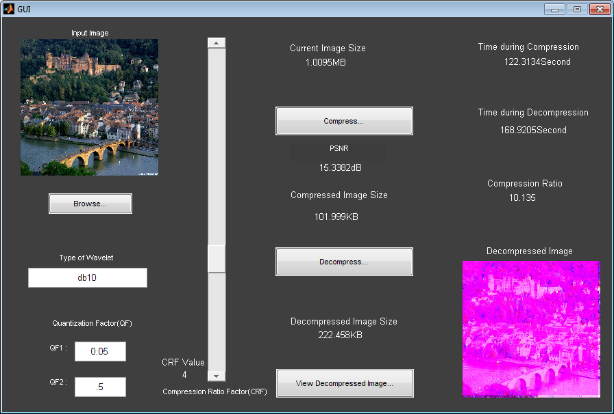**

**Figure 5.18 City image tested in db10 with CRF value 4**

In this figure we use db10 wavelet form on the input image of 1.00 Mb in size and QF form [.05-.5] with CRF value is 4, On compressing we got 102 kb and PSNR is 15.33 dB. We estimated the time during compression that is 122.31 sec . After that when we decompress the image the size is 222.45 kb and time during decompression is 168.92 sec. The compression ratio for that process is 9.07 .

**5.3 Output Images**

The image first shown on the top in Figure no. is the original image and the below images are the outputs from that of original image. The point is that from the original image here we can compare the tested images results. We also see that compressed using Db wavelet method the loss of quality is not visible. Of course, image compression using Db Wavelet is one of the simplest way for compression.

****

**(a)**

**  **

(b) (c) (d)

**  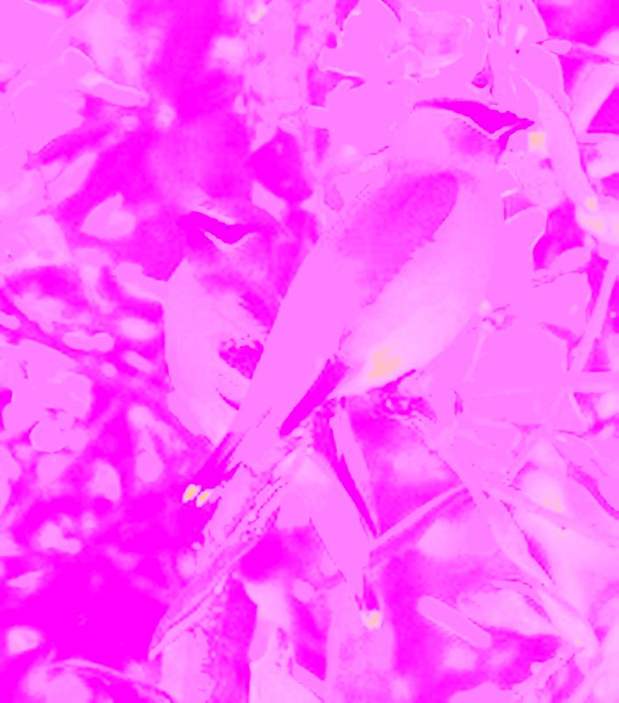**  **(e) (f) (g)**

**Figure 5.19 Parrot image tested outputs (a) original image (b) db2 with crf 2 (c) db5 with crf 2 (d) db10 with crf 2 (e) db2 with crf 4 (f) db5 with crf 5 (g) db10 with crf 4**

**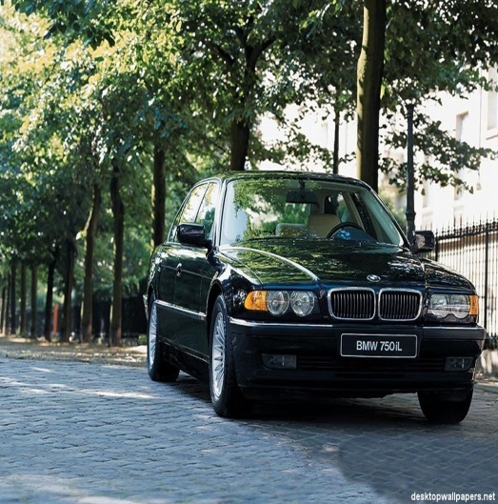  
(a)**

**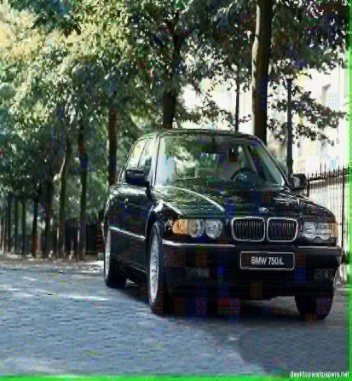 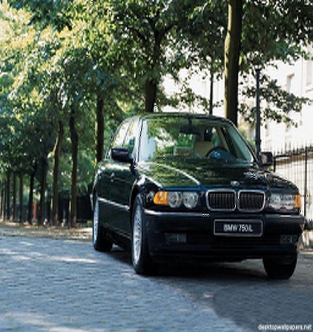 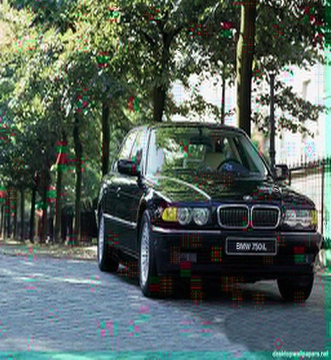**

(b) (c) ( d)

**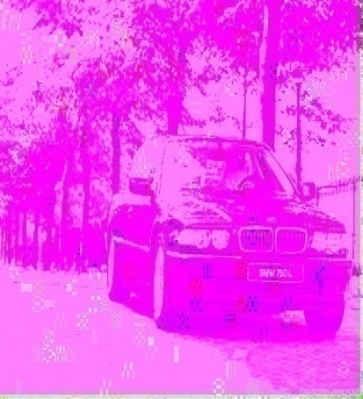 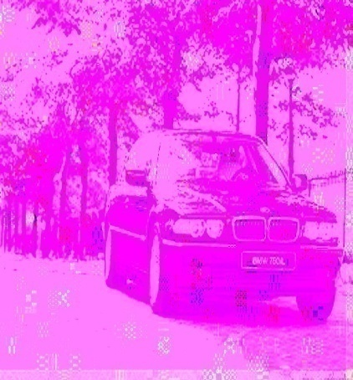 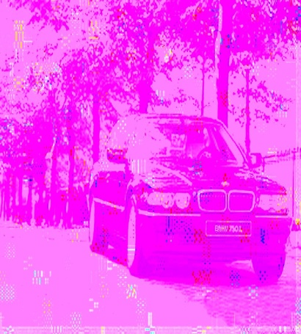**

(e) (f) (g)

**Figure 5.20 Car image tested outputs (a) original image (b) db2 with crf 2 (c) db5 with crf 2 (d) db10 with crf 2 (e) db2 with crf 5 (f) db5 with crf 5 (g) db10 with crf 5**

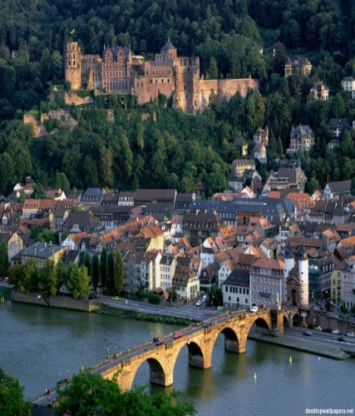

(a)

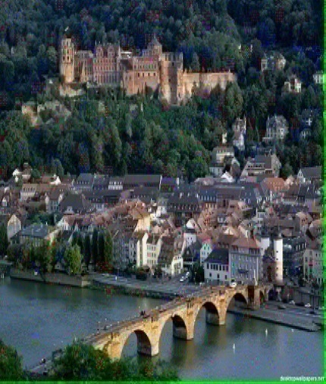 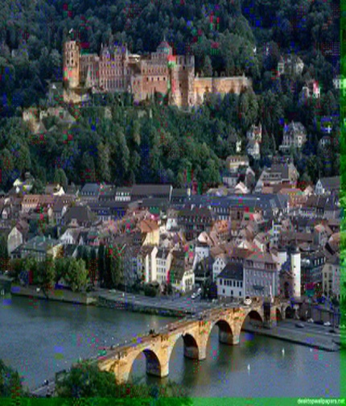 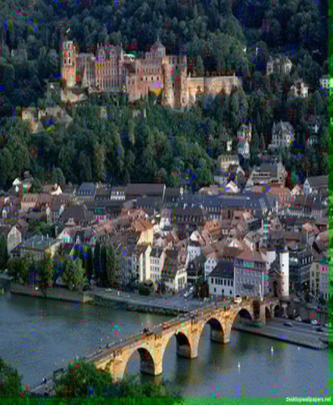

(b) (c) (d)

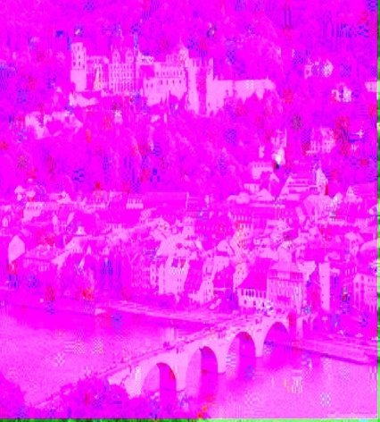 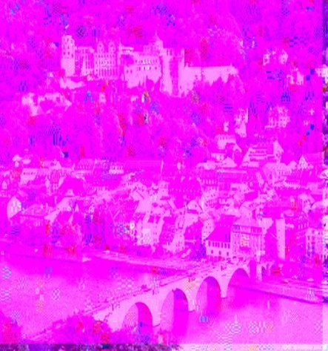 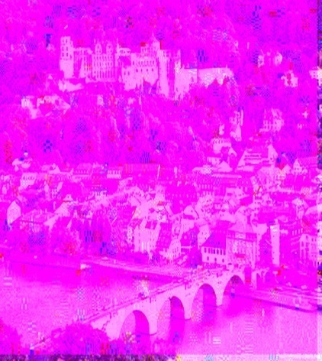

(e) (f) (g)

**Figure 5.21 City image tested outputs (a) original image (b) db2 with crf 2 (c) db5 with crf 2 (d) db10 with crf 2 (e) db2 with crf 5 (f) db5 with crf 5 (g) db10 with crf 5**

Our results show that reconstructed image using Daubachies wavelet with Walsh Tranform makes the image as good quality production and we show this in different Dbs. More detail given in below tables as follows:

**PARROT image with Quantization Factor (.05-.5)**

|  |  |  |  |  |  |  |  |  |  |
| --- | --- | --- | --- | --- | --- | --- | --- | --- | --- |
| **S.No.** | **Wavelet Name** | **CRF** | **Image** | **PSNR** | **Compress** | **Time in** | **Decompress** | **Time in** | **Compression** |
| **size (KB)** | **(dB)** | **size (KB)** | **Compress**  **(Sec)** | **size (KB)** | **Decompress** | **Ratio** |
| 1 | Db2 | 2 | 340.77 | 12.18 | 48.81 | 95.4 | 74.52 | 133.3 | 6.9 |
| 2 | Db5 | 2 | 340.77 | 12.16 | 48.92 | 120 | 67.62 | 108 | 6.9 |
| 3 | Db10 | 2 | 340.77 | 11.68 | 52.61 | 85.3 | 69.1 | 122.1 | 6.4 |
| 4 | Db2 | 4 | 340.77 | 11.93 | 50.63 | 30.66 | 71.67 | 28.5 | 6.7 |
| 5 | Db5 | 4 | 340.77 | 11.89 | 50.89 | 30.04 | 66.12 | 35.89 | 6.6 |
| 6 | Db10 | 5 | 340.77 | 12.76 | 45.09 | 73.62 | 59.9 | 107.51 | 7.5 |

**Table No. 5.1 Parrot Image Implementation Results**

**Car image with Quantization Factor (.05-.5)**

|  |  |  |  |  |  |  |  |  |  |
| --- | --- | --- | --- | --- | --- | --- | --- | --- | --- |
| **S.No.** | **Wavelet Name** | **CRF** | **Image** | **PSNR** | **Compress** | **Time in** | **Decompress** | **Time in** | **Compression** |
| **size (KB)** | **(dB)** | **size (KB)** | **Compress**  **(Sec)** | **size (KB)** | **Decompress** | **Ratio** |
| 1 | Db2 | 2 | 355.85 | 11.25 | 58.77 | 54.54 | 174.18 | 83.51 | 6.0 |
| 2 | Db5 | 2 | 355.85 | 10.31 | 69.56 | 38.04 | 122.53 | 76.76 | 5.1 |
| 3 | Db10 | 2 | 355.85 | 10.03 | 73.67 | 34.04 | 134.119 | 89.75 | 4.83 |
| 4 | Db2 | 4 | 355.85 | 11.64 | 55.26 | 40.80 | 144.10 | 61.50 | 6.4 |
| 5 | Db5 | 4 | 355.85 | 11.52 | 56.26 | 38.03 | 133.35 | 60.18 | 6.3 |
| 6 | Db10 | 4 | 355.85 | 11.15 | 59.82 | 49.82 | 133.70 | 63.01 | 5.9 |

**Table No. 5.2 Car Image Implementation Results**

**City image with Quantization Factor (.05-.5)**

|  |  |  |  |  |  |  |  |  |  |
| --- | --- | --- | --- | --- | --- | --- | --- | --- | --- |
| **S.No.** | **Wavelet Name** | **CRF** | **Image** | **PSNR** | **Compress** | **Time in** | **Decompress** | **Time in** | **Compression** |
| **size (KB)** | **(dB)** | **size (KB)** | **Compress**  **(Sec)** | **size (KB)** | **Decompress** | **Ratio** |
| 1 | Db2 | 2 | 1024 | 14.28 | 113.88 | 116.10 | 237.39 | 236.84 | 9.0 |
| 2 | Db5 | 2 | 1024 | 14.21 | 114.71 | 121.59 | 215.08 | 242.39 | 9.0 |
| 3 | Db10 | 2 | 1024 | 13.85 | 119.46 | 145.00 | 205.30 | 257.99 | 8.6 |
| 4 | Db2 | 4 | 1024 | 15.77 | 97.82 | 85.66 | 240.92 | 178.04 | 10.56 |
| 5 | Db5 | 4 | 1024 | 15.66 | 98.81 | 116.21 | 223.70 | 191.51 | 10.46 |
| 6 | Db10 | 4 | 1024 | 101.99 | 101.99 | 122.31 | 222.45 | 168.9 | 10.13 |

**Table No. 5.3 City Image Implementation Result**

**Table 5.4 Comparison of Parrot image PSNR values with different wavelet type(Db)**

**Table 5.5 Comparison of Car image PSNR values with different wavelet type(Db)**

**Table 5.6 Comparison of City image PSNR values with different wavelet type(Db)**

**CHAPTER 6**

**CONCLUSION AND FUTURE WORK**

**6.1 Conclusions**

The WT is a powerful tool to analyze signals. There are many applications of the WT, such as image compression. Daubechies wavelet transform for image compression is simple and crudest algorithm as compared to other algorithms it is more effective. The quality of compressed image is also maintained. In this paper, we present an image compression framework that adopts Daubechies wavelets with Walsh Transform to remove redundancy from images. Wavelet decomposes a signal into a set of basis functions these basis of function are called wavelets. In this correspondence, we have proposed an improved image compression algorithm. Due to the delivered assistant information, our presented framework is able to remove enough regions so that the compression ratio can be greatly increased. Our presented Daubechies wavelets with Walsh Transform method is capable in effectively restoring the removed regions for good visual quality, as well.

**6.2 Future Work**

Our future work is to improve them. For example, we could improve the adaptive transform coding, including the shape of the sub images, the selection of transformation, and the quantizer design. They are all hot topics to be studied. In future we can extend the picture quality with the increasing compressed ratio factor also we can extend this method for image compressing from input image by using interactive compression techniques and different transform apply on these techniques as well as using different discrete wavelet like produce better results with minimizing noise to improve the compression. Furthermore, image compression is still a challenging problem when some kinds of assistant information are provided, into which we need to put more effort in the future.

**REFERENCES**

[1] Liu Bo, Yang Zhaorong Harbin University of Science and Technology Harbin China Image Compression Based on Wavelet Transform ©2012 IEEE proceeding of International Conference on Measurement, Information and Control (MIC)

[2] G Boopati, Dr.S. Arockiasamy “An Image Compression Approach using Wavelet Transform and Modified Self Organizing Map” IJCSI International Journal of Computer Science Issues, Vol. 8, Issue 5, No 2, September 2011

|  |
| --- |
|  |

[3] Myung-Sin Song Wavelet Image Compression1991 Mathematics Subject Classification. Primary 42C40.

[4] Davis,G.Danskin,J and Heasman R wavelet image compression construction kit,HTTP://www.cs.darthmouth.edu/gdavis/wavelet/wavelet.html> 2002 March12

[5] Chin,C “ An Introduction to wavelets,San Diego: Academic press Inc

[6] *Matthew C. Stamm and K. J. Ray Liu* **WAVELET-BASED IMAGE COMPRESSION ANTIFORENSICS** Proceedings of 2010 IEEE 17th International Conference on Image Processing September 26-29, 2010, Hong Kong

[7] M. Saenz, R. Oktem, K. Egiazarian, , and E. Delp. Color image wavelet compression using vector morphology. Proc. of the European Signal Processing Conference, September.

[8] <http://en.wikipedia.org/wiki/quantization>\_ detail

[9] J. Shapiro, Dec. 1993. Embedded image coding using zero trees of wavelets coeNcients, IEEE Trans. Signal Processing, vol. 41,no. 12, pp. 3445–3462

[10] J. M. Shapiro, April 1993,Application of the embedded wavelets hierarchical image coder to very low bit rate image coding,Proc. ICASSP, Minneapolis,MN,

[11] Smart Compression using the Embedded Zero tree Wavelets (EZW) Algorithm Jerome M. Shapiro David Sarnoff Research Center, CN5300, Princeton, NJ 08543-5300

[12] F. W. Wheeler and W. A. Pearlman, Low-memory packetized SPIHT image compression, 33rd AsilomarN.

[13] A. Said and W. A. Pearlman, Jun. 1996,A New, Fast and Efficient Image Codec based on Set Partitioning in Hierarchical trees, IEEE Trans. Circuits Syst. Video Technology, vol. 6, pp. 243–250

[14] Lu and W. A. Pearlman, Dec.1998, An Efficient, Low- Complexity Audio Cider Delivering Multiple Levels of Quality for Interactive Applications, IEEE Workshop on Multimedia Signal Processing,.

[15] Sprljan, S. Grgic and M. Grgic, , Aug. 2005,Modified SPIHT Algorithm for Wavelets Packet Image Coding, Real-Time Imaging, Elsevier, vol. 11, pp. 378-388

[16] Aditya Kumar et al.International Journal on Computer science and engineering (IJCSE),A Wavelets Transform algorithm for 2^n Shades Images.5-8 2000.

[17] Dr. (Mrs.) R.Sukanesh, R.Harikumar,N.S.Balaji and S.R.Balasubramaniam , “Analysis of Image Compression by Minimum Relative Entropy (MRE) and Restoration through Weighted Region Growing Techniques for Medical Images” , Engineering Letters, 14:1, EL\_14\_1\_16 , 2007.

[18] K. Veeraswamy, S. Srinivas Kumar , “Adaptive AC-Coefficient Prediction for Image Compression and Blind Watermarking”, Journal of Mutltimedia, VOL. 3, NO. 1, MAY 2008.

[19] Jagadish H. Oujar,Lohit M. Kadlaskar , “ A New Lossless Method of Image Compression and Decompression using Huffman Coding Techniques”, Journal of Theoretical and Applied Information Technology © 2005 - 2010 JATIT.

[20] G.M.Padmaja, P.Nirupama , “Analysis of Various Image Compression Techniques”, ARPN Journal of Science and Technology ©2011-2012..

[21] S.Parveen Banu Dr.Y.Venkataramani , “An Efficient Hybrid Image Compression Scheme based on Correlation of Pixels for Storage and Transmission of Images”, International Journal of Computer Applications (0975 – 8887) Volume 18– No.3, March 2011.

[22] Yu Yanxin , Song Xue , “A Remote Sensing Image Compression Method Suited to Space-borne Application”, 2011 International Conference on Computer Science and Network Technology.

[23] Baluram Nagaria , Mohammad Farukh Hashmi ,Imran Hussain ,Ravijeet Singh Chauhan ,” Comparative Analysis of an Optimal Image Compression using FDWT at Various Decomposition Level with Different Statistical Numerical Measures for Different Pixel Frame”, 2011 International Conference on Computational Intelligence and Communication Systems.

[24] Yu Shen, , Xieping Gao, Linlang Liu, Caixia Li, Qiying Cao , “Integer to Integer Multiwavelets for Lossless Image Compression”, Proceedings of IEEE IC-BNMT2011.

[25] S.P. Raja , Dr. A. Suruliandi **Analysis of Efficient Wavelet based Image Compression Techniques** 2010 Second International conference on Computing, Communication and Networking Technologies *Manonmaniam Sundaranar University, Tirunelveli, Tamilnadu, India*

[26] K. Sayood, *Introduction to Data Compression*, Second edition, Academic Press, 2000.

[27] G.M. Davis, A. Nosratinia. “*Wavelet-based Image Coding: An Overview. Applied and Computational Control*”, Signals and Circuits, Vol. 1, No. 1,1998.

[28] Internet. “*PSNR”,* <http://en.wikipedia.org/wiki/PSNR_Page>

[29] **Karen Lees** Dr. Joab Winkler **Image Compression Using Wavelets 2002**

[30] [http://en.wikipedia.org/wiki/wavelet transform](http://en.wikipedia.org/wiki/wavelet%20transform%20quantization)

[31] Cédric Vonesch Generalized Daubechies Wavelet Families IEEE TRANSACTIONS ON SIGNAL PROCESSING, VOL. 55, NO. 9, SEPTEMBER 2007

[32] [http://en.wikipedia.org/wiki/](http://en.wikipedia.org/wiki/quantization)

**PAPER PUBLISHED**